**Q.1) Host windows instance and use rdp to connect .**

**🡺**

**step 1:-**

**First Of all logging to AWS account and go to ec2 service .**

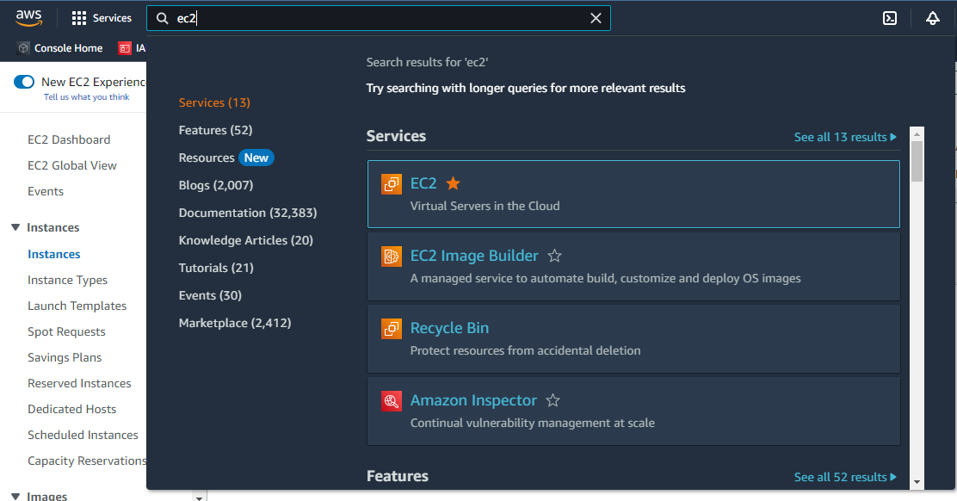

**Step 2:-**

**After that create instance with select image of windows to launch that instance. And then connect instance by select instance and click connect. Whene you select instance that you have to add port number of RDP service 3389 in security group.**

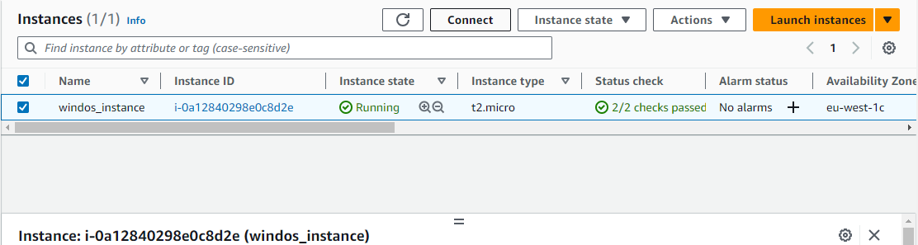

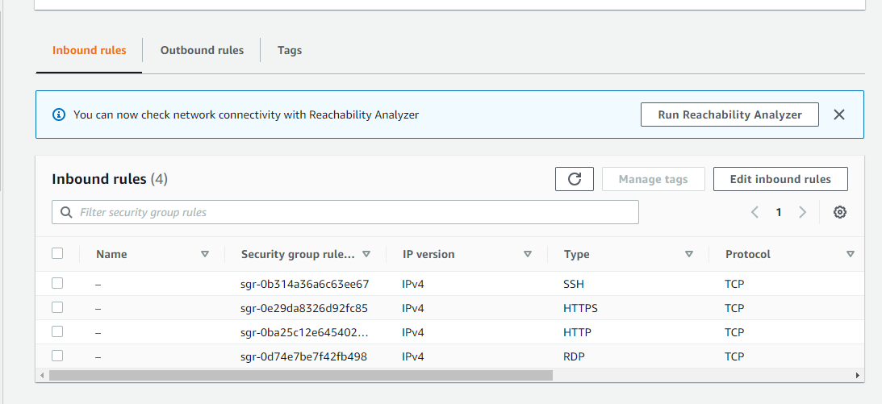

**Step 3:-**

**After that click on RDP client option for decrypt password of instance.**

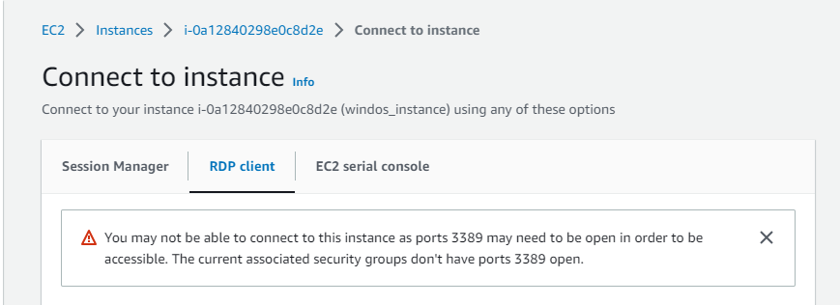

**Step 4:-**

**Next you have to click on get password option.**

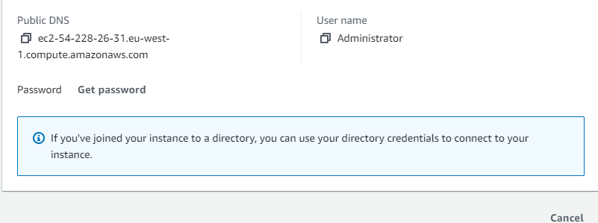

**Step 5:-**

**Now you have to upload a private key by click on upload private key file. And then click on decrypt password.**

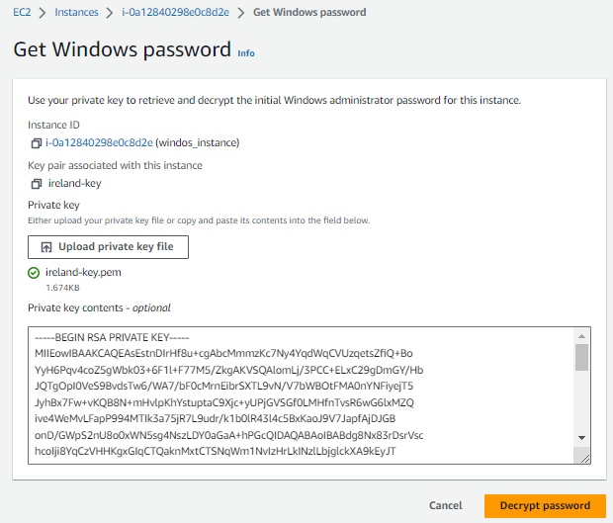

**Step 6:-**

**Then copy your instance’s decrypted password.**

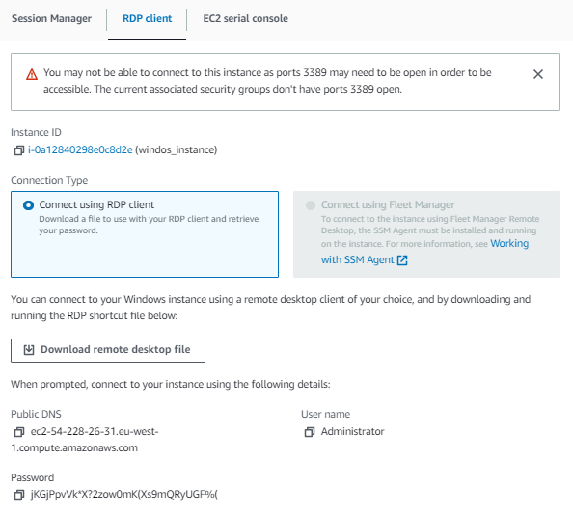

**Step 7:-**

**Then go to third party app of get access of instance by RDP. I have choose a moboxtream. And public ip address in remote host column and in username column Put user name Administrator. And click on ok.**

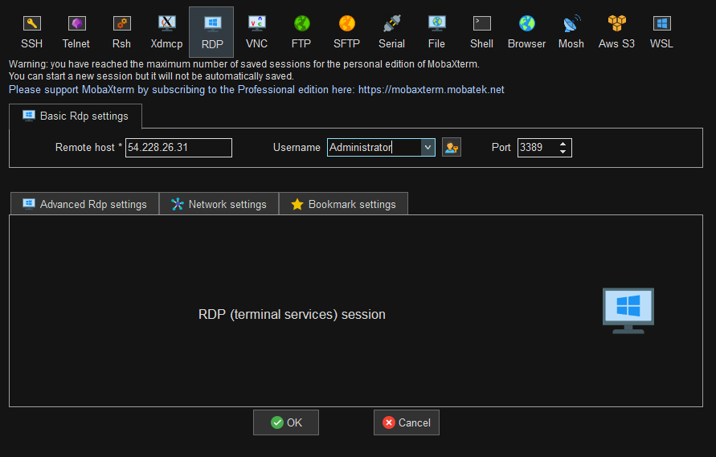

**Step 8:-**

**Now you have display the password column paste there a decrypted password.**

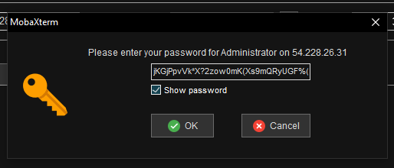

**Step 9:-**

**Your windows instance access by RDP is ready.**

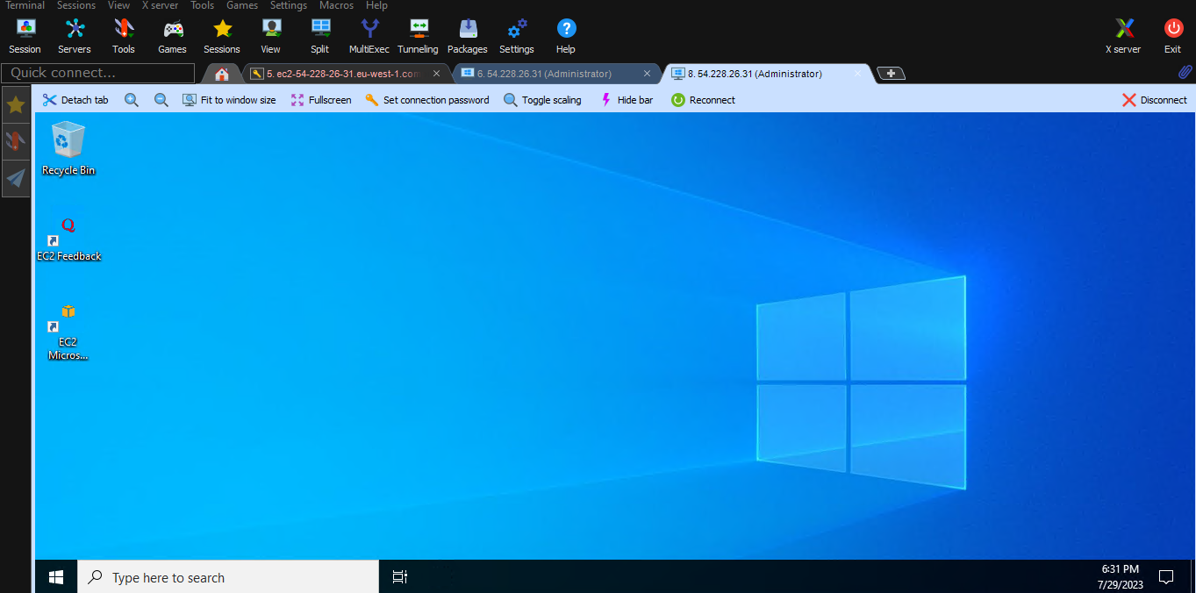

**Q.2)create ami of ubuntu OS host NGNIX page. share AMI to mumbai and Oregon region. also make it public.**

**🡺**

**Step 1:-**

**Login to AWS account and go to ec2 service.**



**Step 2:-**

**After that launch a instance with selecting image of Ubuntu.**

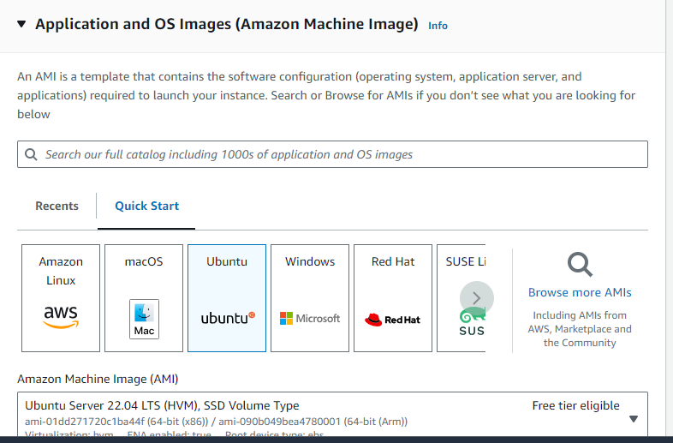

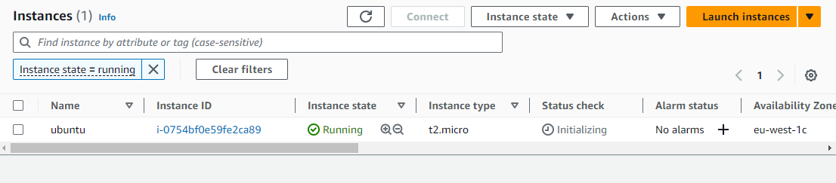

**Step 3:-**

**After that get access of that instance by third party app or directly connected to AWS cloudshell. I have get access on cloudshell.**

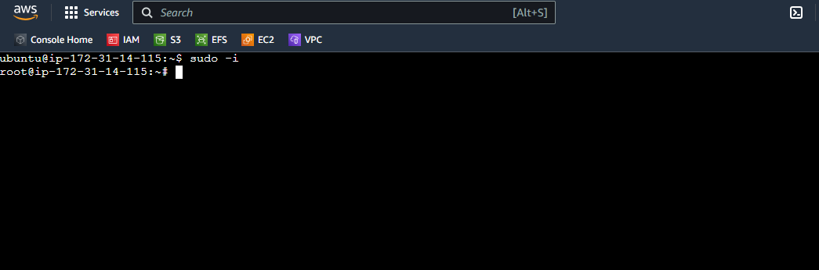

**Step 4:-**

**After install that NAGINX service by apt command. And configure it by systemctl command.**

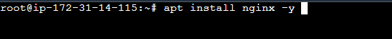

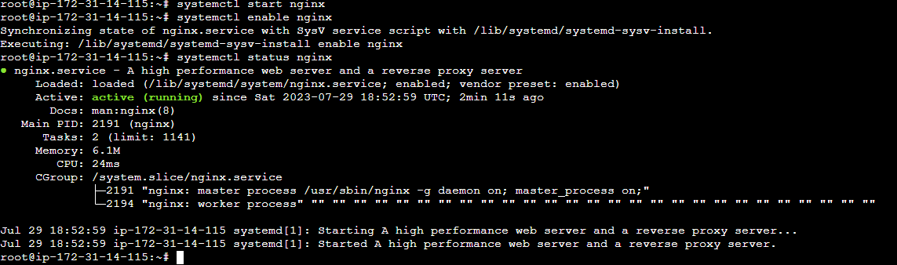

**Step 5:-**

**After that create your web page by index.html in /var/www/html/index.html**

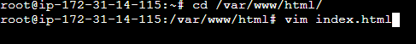

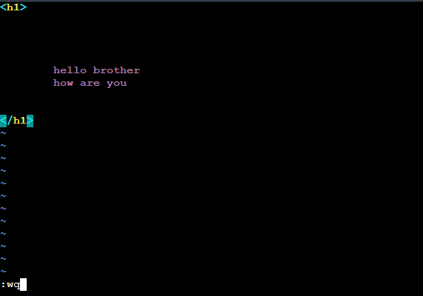

**Step 6:-**

**Now curl localhost or by ip see your page is hosting properly.**

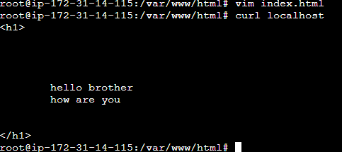

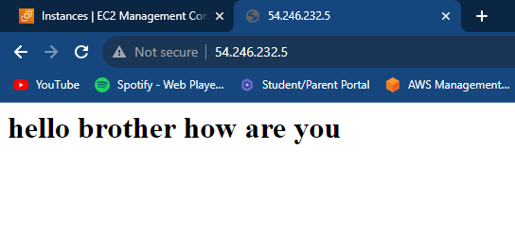

**Step 7:-**

**Now you have to create your instance image. Select instance and then click on actions and then image and template sub option click and after that create image.**

**See to following image how to create image.**

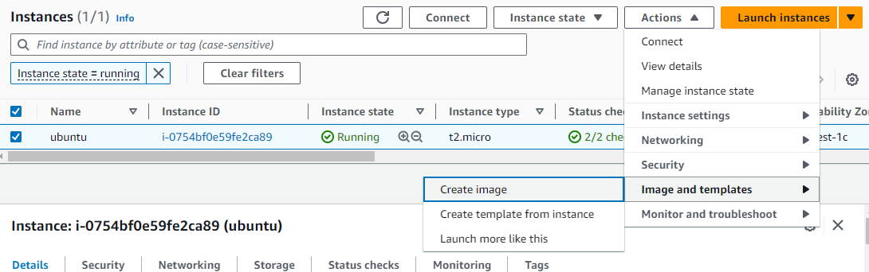

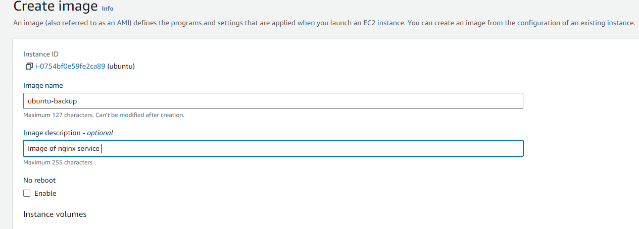

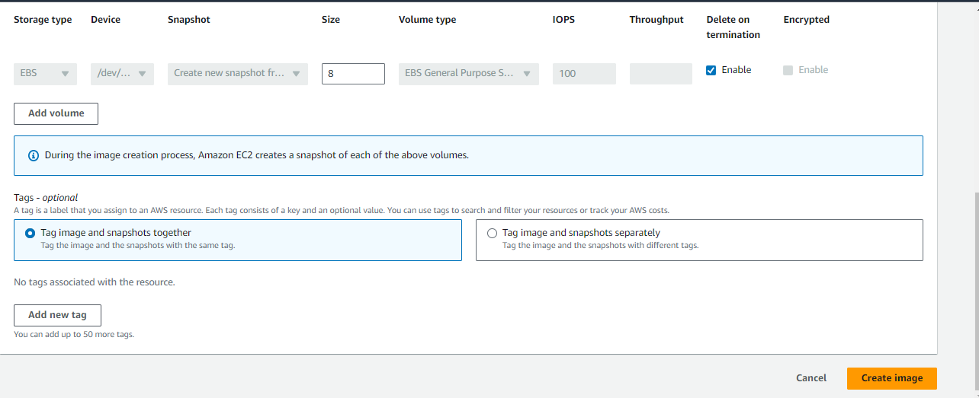

**Step 8:-**

**Now go to AMIs option to see your image is created or not and after that select instance .**

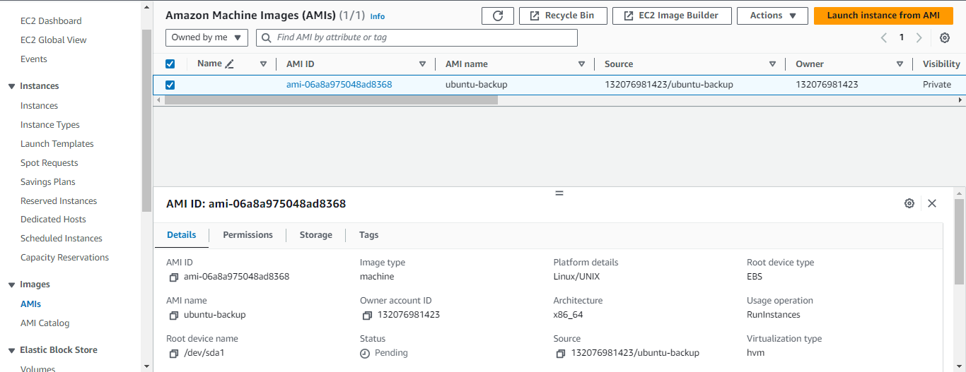

**Step 9:-**

**Now select instance and click on edit AMI permission to get access to private or public.**

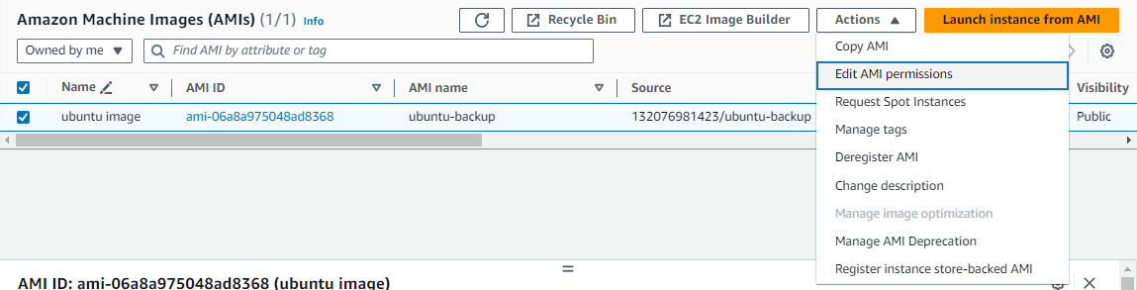

**Step 10:-**

**Now you have to click on public to create your AMI publicly access and then save changes.**

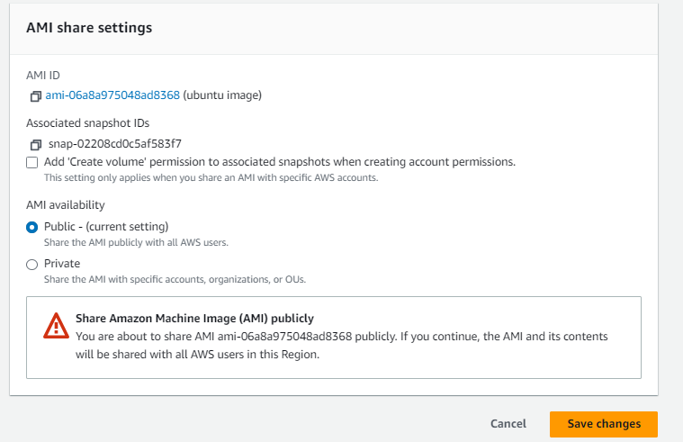

**Step 11:-**

**Now you have share AMI to mumbai and Oregon region. So select and click on actions and after that click on copy AMI.**

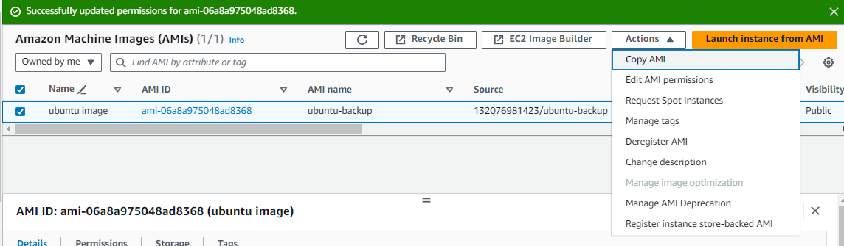

**Step 12:-**

**Now select region Mumbai to copy your AMI there. And repeat it and then next time select origin region. And after that click on copy AMI.**

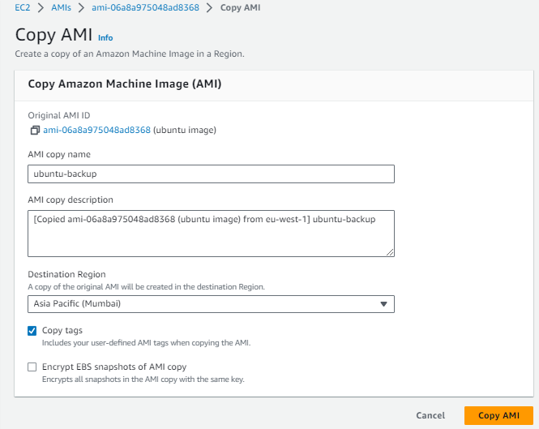

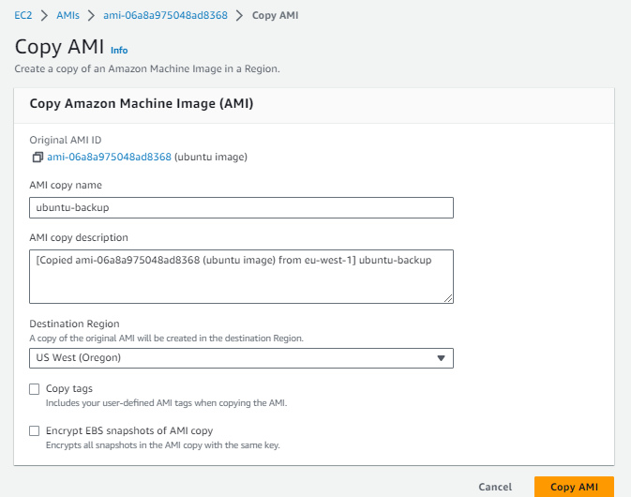

**3.create snapshot of your instance create volume with that snapshot attch to your diffrent instance also create lifecycle policy for snapshot.**

**🡺**

**Step 1:-**

**Login to AWS account and go to ec2 service.**

**Step 2:-**

**Now you have to take snap shot of your instance. Click on create snapshot .**

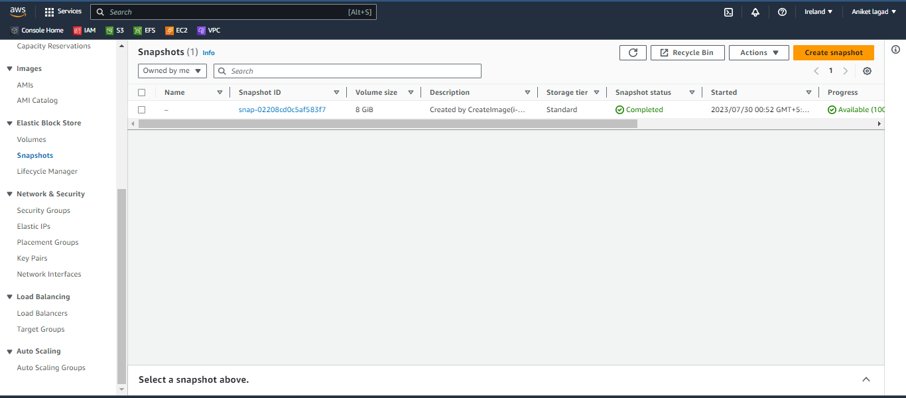

**Step 3:-**

**Now you will see the resource type select the instance to create instances snapshot.**

**After that select your instance and next gave its description .**

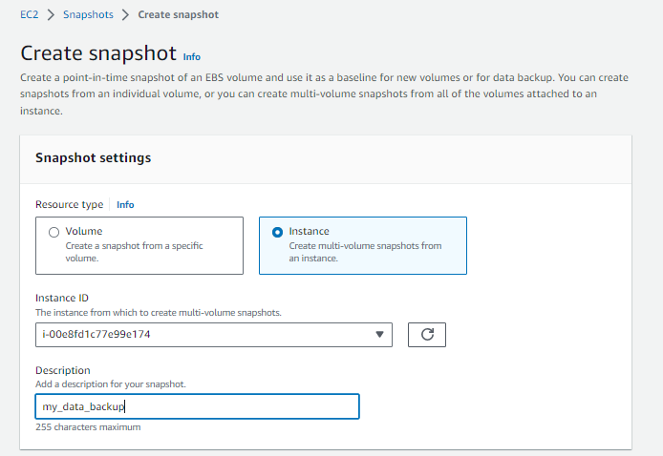

**Step 4:-**

**Next if you have to exclude the root volume or not. And next click on create snapshot to create.**

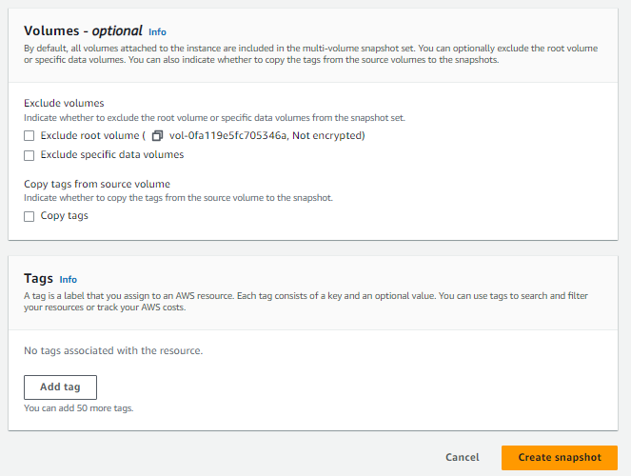

**Step 5:-**

**Your instance snapshot is ready.**

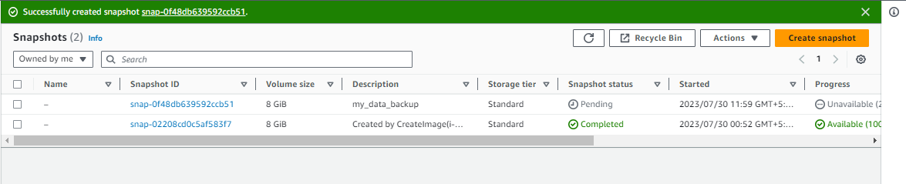

**Step 6:-**

**Now you have to create volume from that snapshot which you have created.**

**So select snapshot and then click on actions and then create volume from snapshot.**

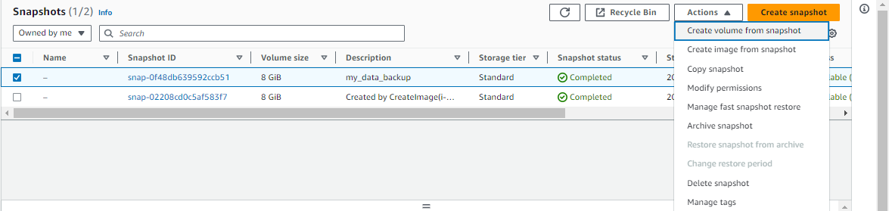

**Step 7:-**

**After that you see create volume setting select which volume type you have to select. And next select size of volume in GB.** 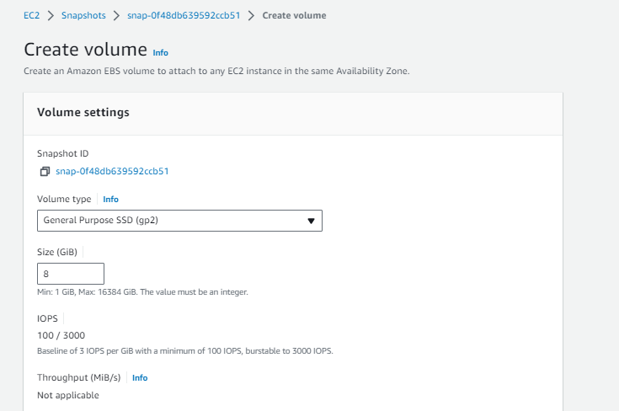

**Step 8:-**

**Now select availability zone and then create volume.**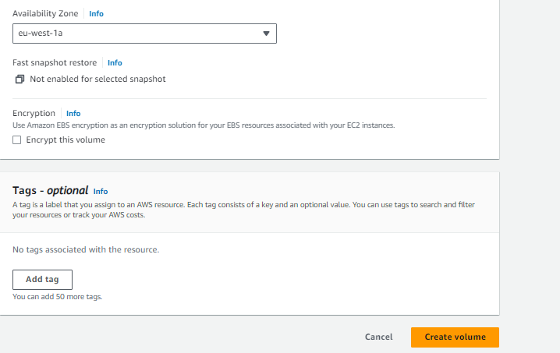

**Step 9:-**

**Now go to the volume session and select volume to attach other instance. Click on actions and attach volume.**

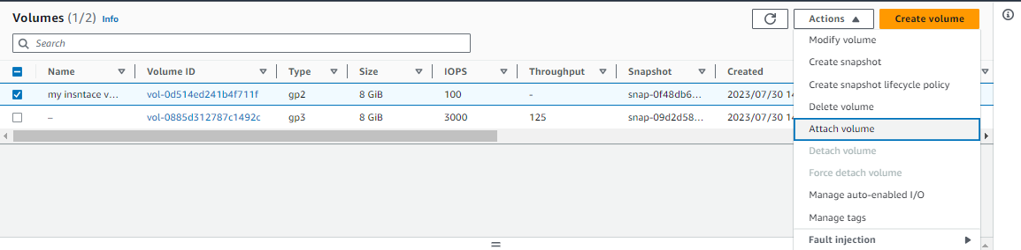

**Step 10:-**

**Now you see the attach volume setting. Select instance of same availability zone in which your volume was created. And after that attach volume. And your instance was successfully attached to instance.**

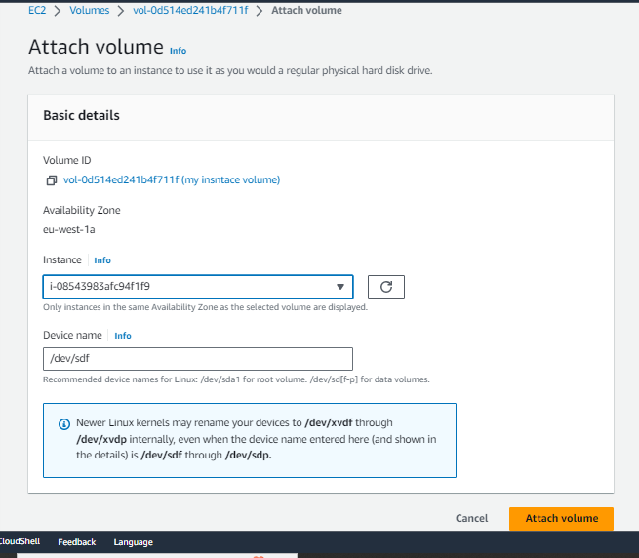

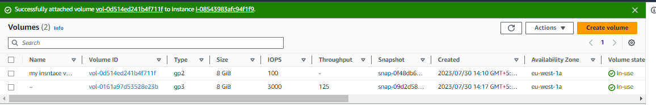

**Step 11:-**

**Now you have to create lifecycle policy of your this snapshot so got lifecycle manager session and after that click on create lifecycle policy.**

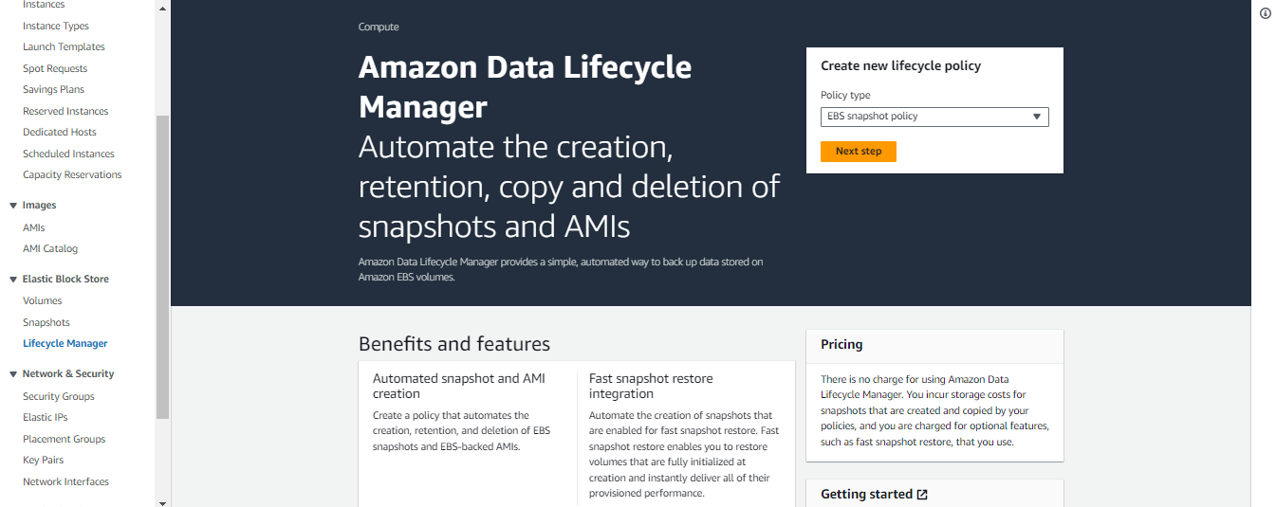

**Step 12:-**

**After that specify setting. First select target resources volume and after that gave it tag and then describe it.**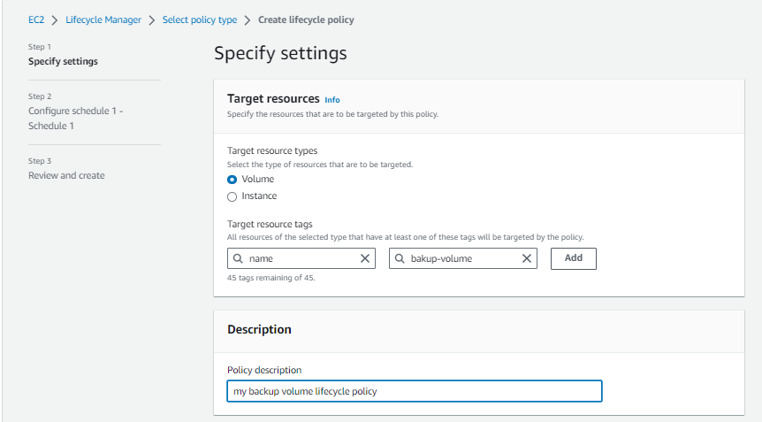

**Step 13:-**

**Now choose role or leave it default role. And then gave it tag and add that tag. And enabled policy status and after that click on next.**

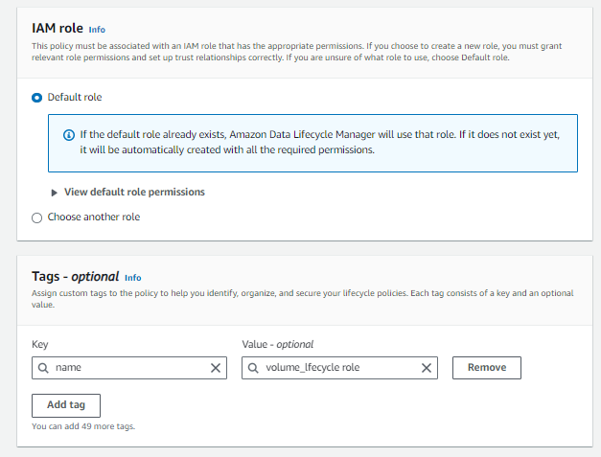

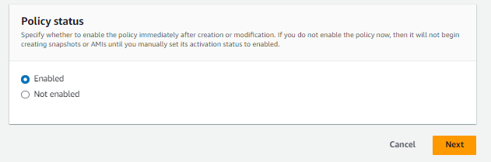

**Step 14:-**

**Now configure schedule your 1st lifecycle. Gave it name and select which day it create after that select hour and next time. And then count how much it run.**

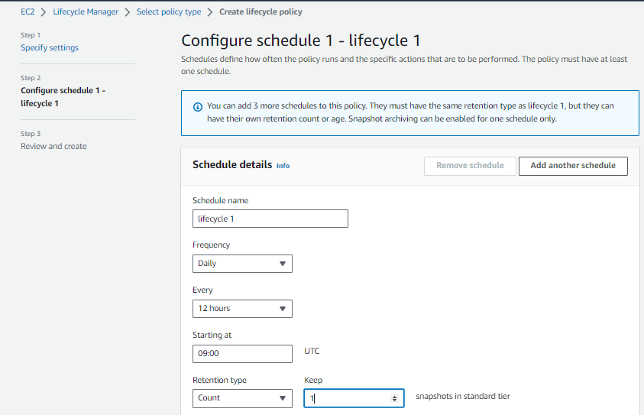

**Step 15:-**

**After that advance setting is there tagging if you have to tag. Then snapshot archiving and then fast snapshot restore if you have fast restore. cross-region copy for cross region sharing. And last is cross account sharing if you want to share your snapshot to particular account on time. And then click review policy.**

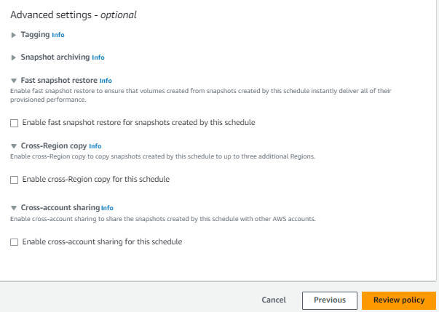

**Step 16:-**

**Next review your policy and create policy if all is correct. And your policy is created.**

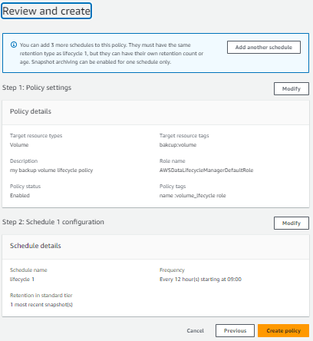

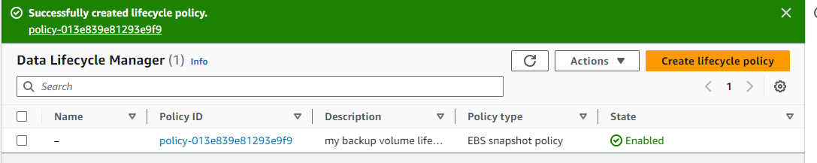

**4.create a security group add ssh,http,and https.launch instance attach security group also asign ilastic ip to that instance**

**🡺**

**Step 1:-**

**Open aws account and go to ec2 service. **

**Step 2:-**

**Then go security group session to create your own security group. Click on create security group.**

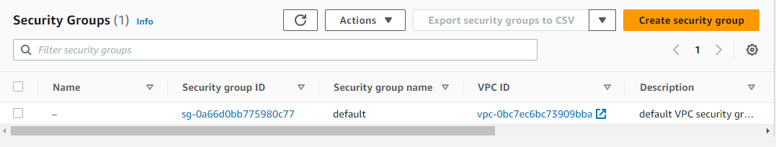

**Step 3:-**

**Now you see column of security group name gave it name. and describe it in description column.**

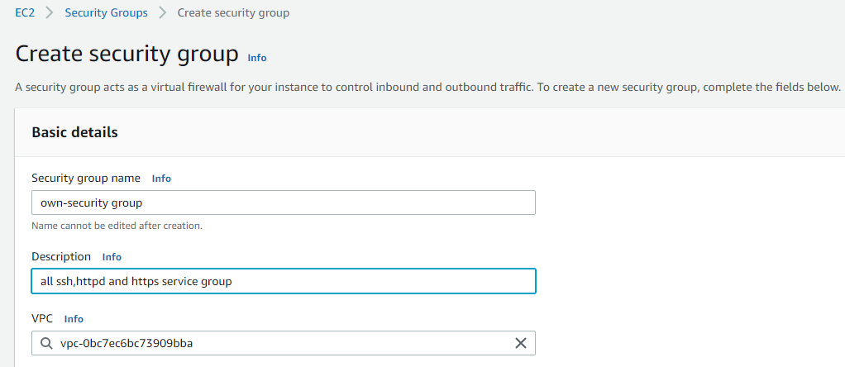

**Step 4:-**

**Next select inbound rules. I added ssh,http and https with port no. 22,80 and 443.**

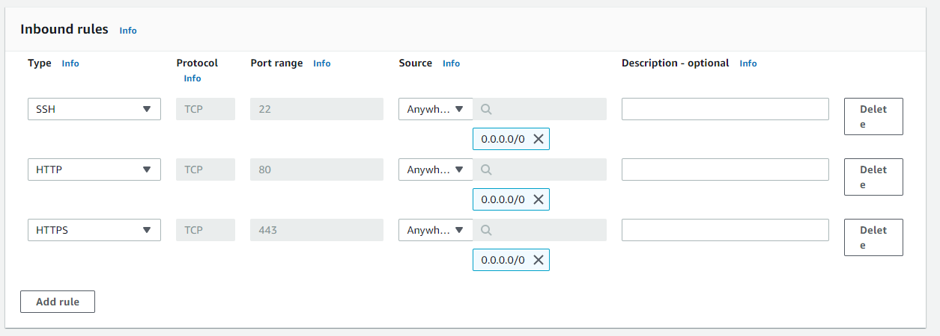

**Step 5:-**

**After that select outbound rues if you have to added outbond rules. Nextx create security group.**

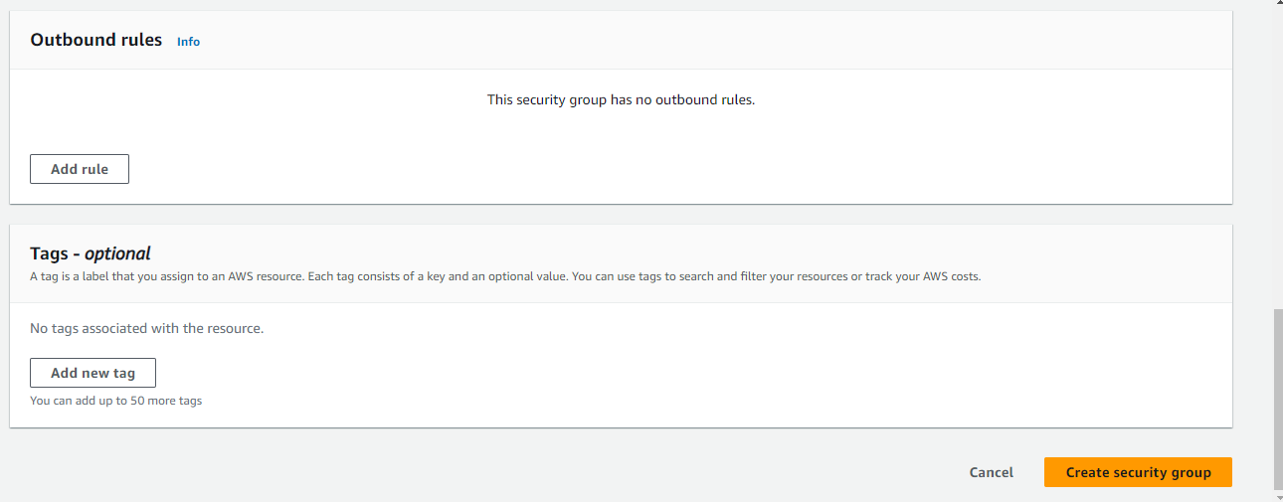

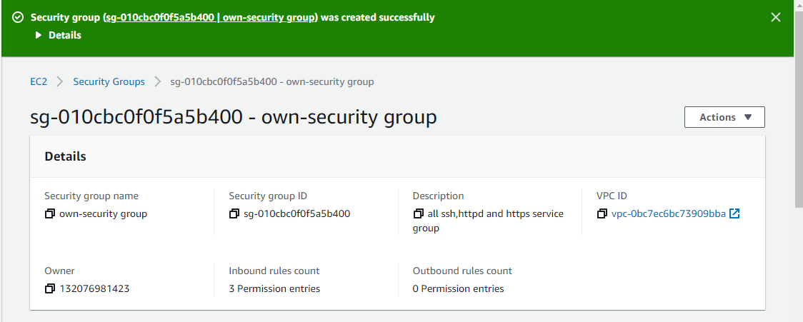

**Step 6:-**

**Now you have to create instance with your own security group. So go to instance session to launch instance and then click on launch instance and create instance with your own security group of ssh httpd and https.**

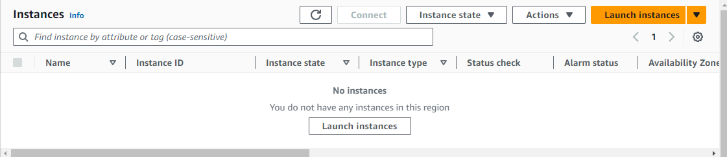

**Step 7 :-**

**And instance is ready with your own security group.**

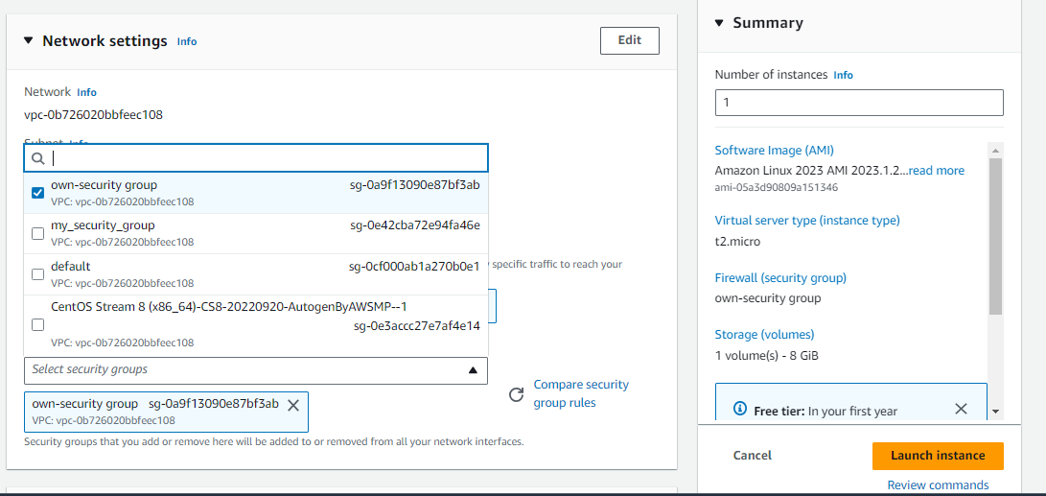

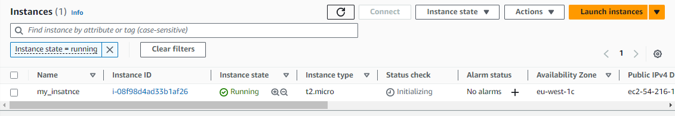

**Step 8:-**

**Now you have to gave it elastic ip address. Go to elastic ip session and click on allocate elastic ip addess.**

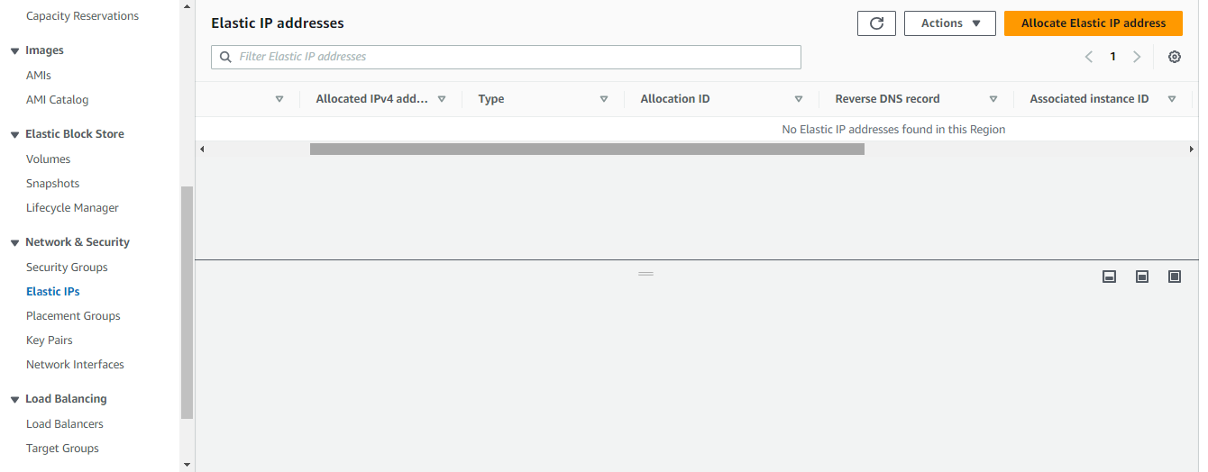

**Step 9:-**

**Now you see allocate elastic ip addess setting. Select amazon’s pool of ipv4 addesses for get public ipv4 address.**

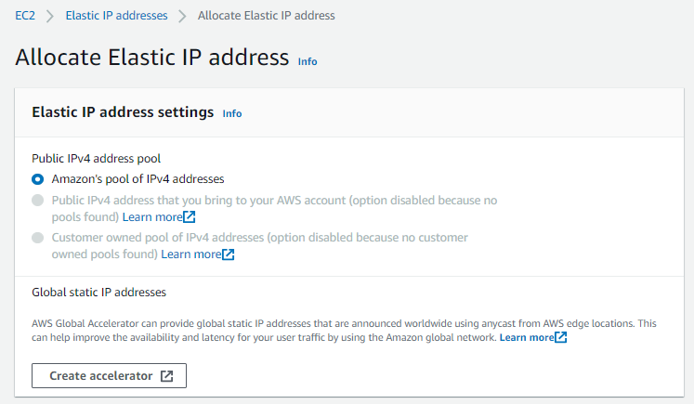

**Step 10:-**

**Next gave tag if you want to gave and click on allocate.**

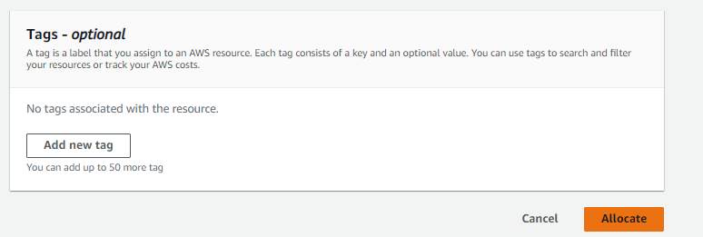

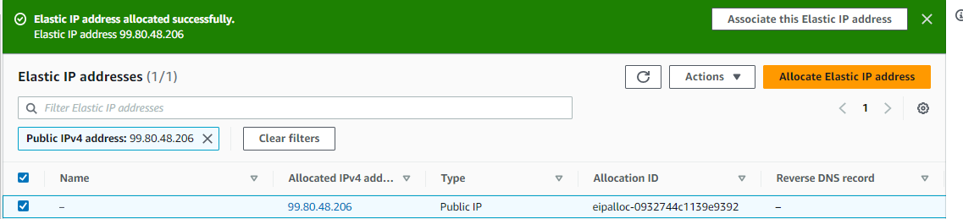

**Step 11:-**

**Now select that elastic ip and click on actions and associate elastic ip address**

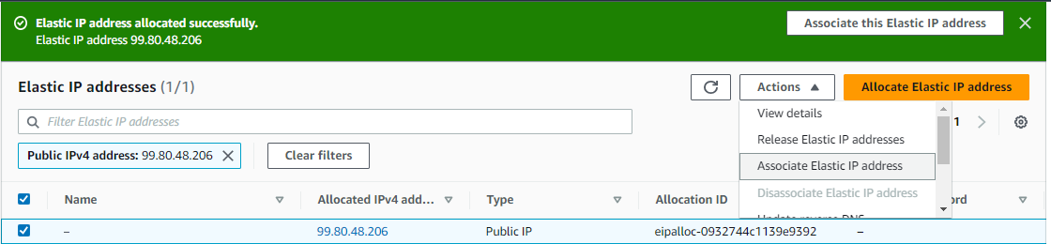

**Step 12:-**

**Now select where to associate that elastic ip address inace or network interface. I selected instance.**

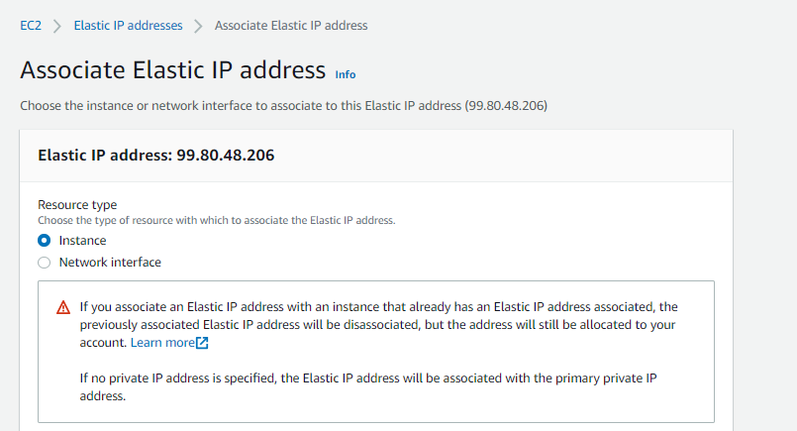

**Step 13:-**

**Now select your instance which you have to associate elastic ip address and select private ip address. And click on associate and your ip elastic ip was associated.**

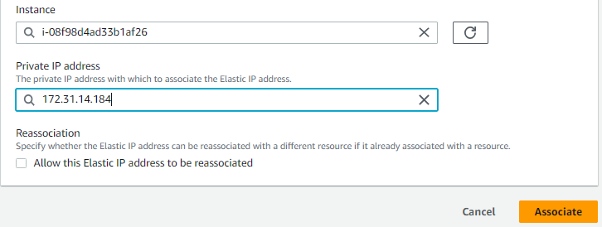

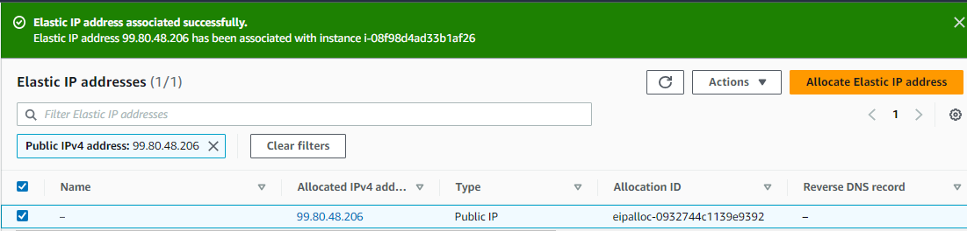

**Step 14:-**

**Now you see the your instance has associated a new private ip address it means elastic ip.**

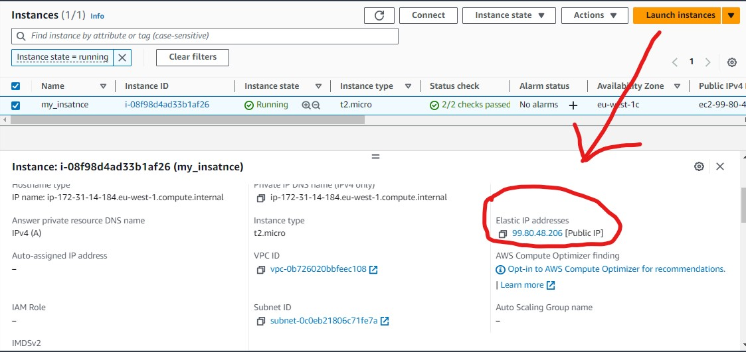

**5.create universal globale key for all your regions and launch intance with that key also take ssh with same private key**

**🡺**

**Step 1:-**

**First of all login to aws account and go to ec2 service to create universal key.**



**Step 2:-**

**Now go to key pair session and click on actions option and then click on import key pair.**

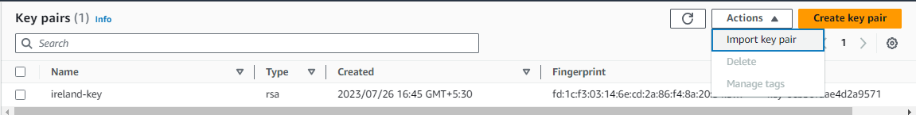

**Step 3:-**

**After that gave key name .**

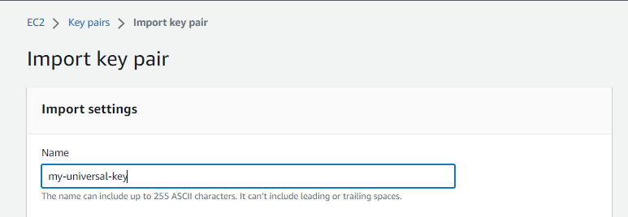

**Step 4:-**

**Next you have to upload a key pair file or public key contents which have easy do that. For public key pair file or content you have to first create by ssh service and then you can copy paste that key content here and then click on import key. First I have to create pub and pri key.**

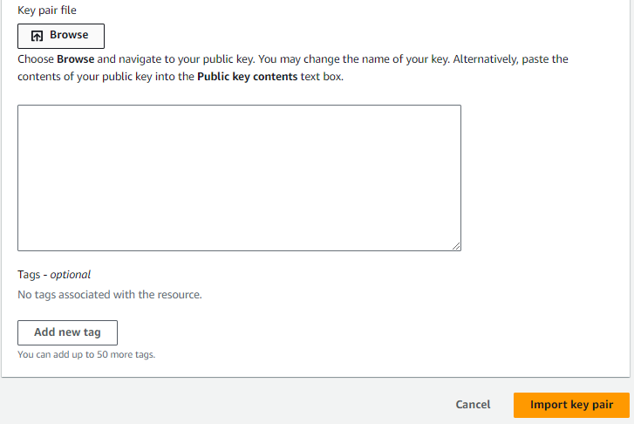

**Step 5:-**

**Now get a access of any instance to create a public and and private keys by ssh service .**

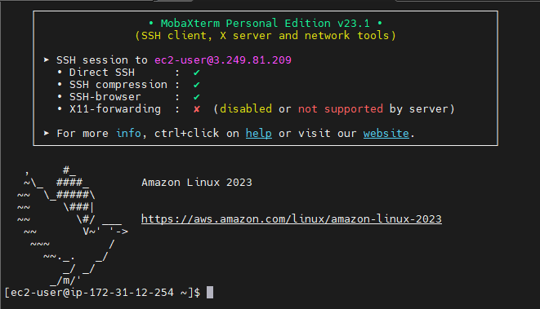

**Step 4:-**

**Now you have to command ssh-keygen and after that store key to where you want. After your key generated go to .ssh name directory in which that pub and pri key are store.**

**And run command ls and see keys was generated or not .** 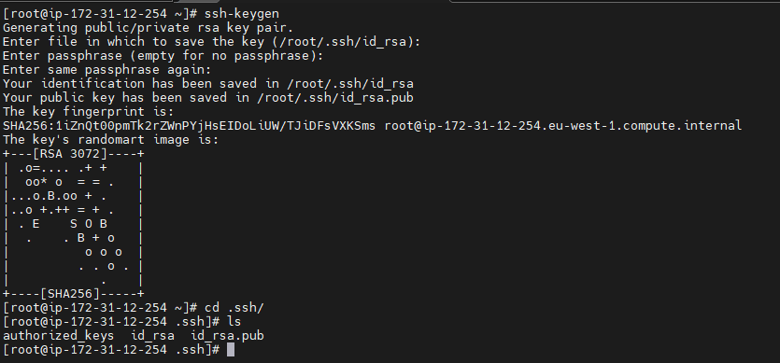

**Step 5:-**

**Now cat id_rsa.pub data and copy it and paste to the key-pair session. Then click on import key pair. And your public key is ready.**



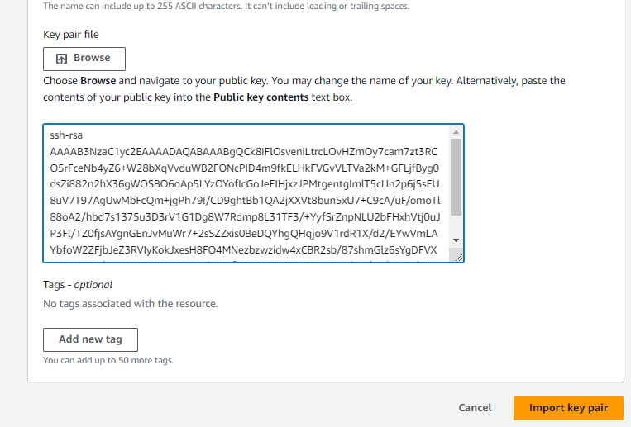

**Step 6:-**

**Now you have to save your private key in a file so you can get access of instance by your private key. For save your private you have so many option but I will copy the key and make it file in my windows. See following images.Go to .ssh directory and cat id_rsa and copy that data make it file by note pad by name Europe-private-key. Now you have private key also.**

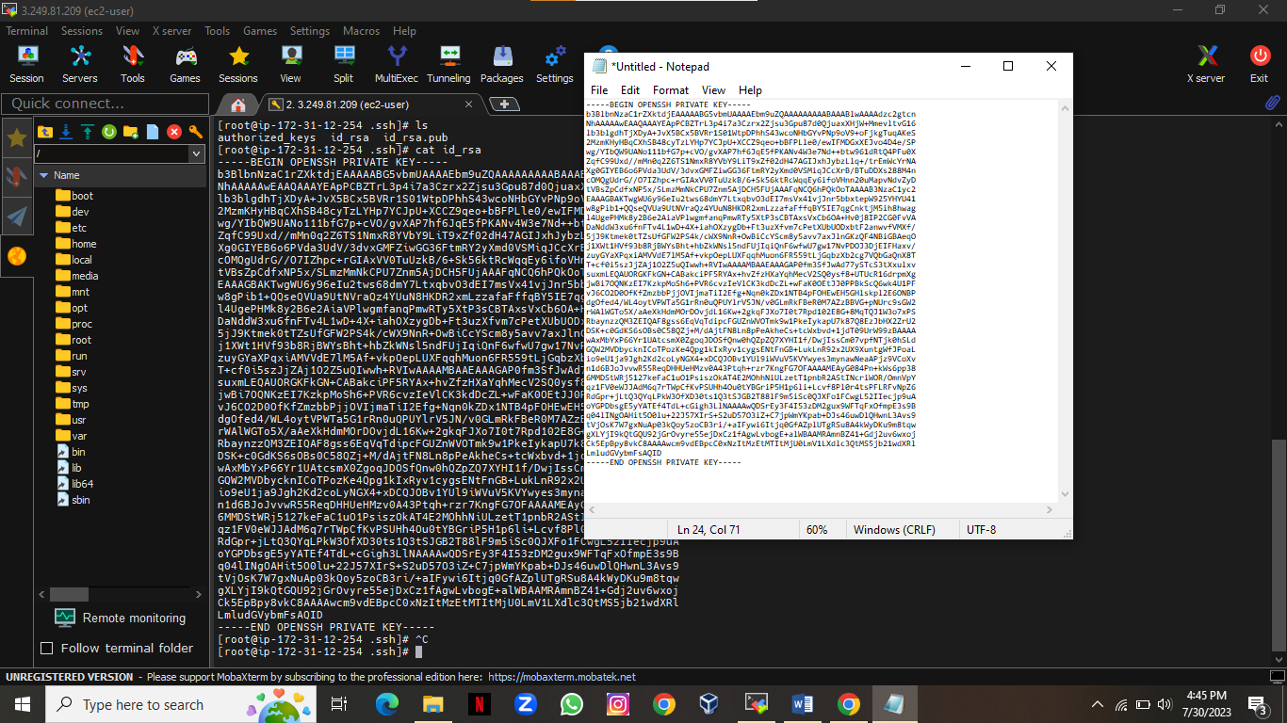

**Step 7:-**

**Now create instance by universal key and get that instance access by your private key.**

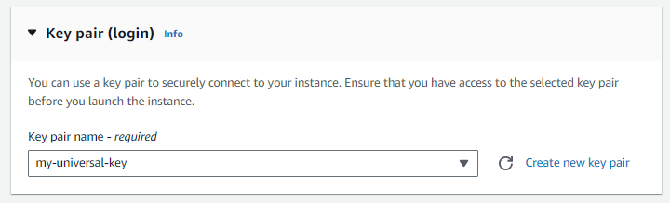

**Step 8:-**

**I have gate access by my universal key.**

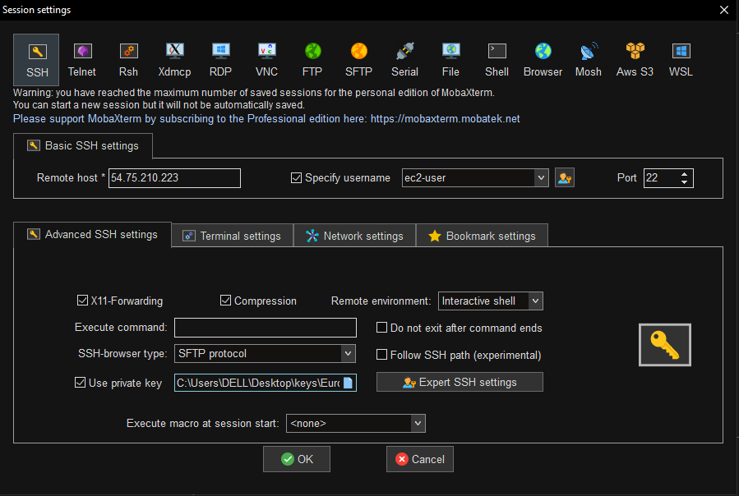

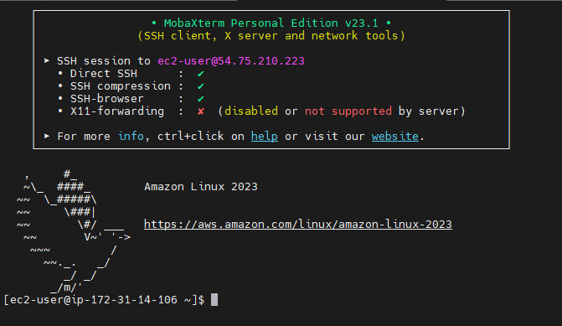

**6.create application load balancer add multiple target group it should be able to balance load to diffrent instance in difrent availability zone.**

**🡺**

**Step 1:-**

**Login AWS account and go to ec2 service for carete load balancer.**



**Step 2:-**

**Create instances two home pages and two mobile pages.**

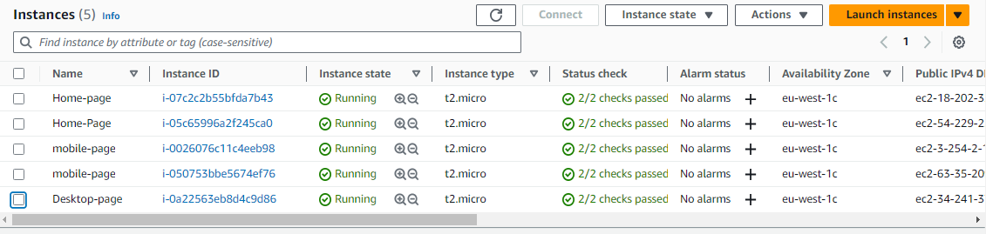

**Step 3:-**

**Now go to target group session to create target group to attach load balancer.**

**Click on create target group.**

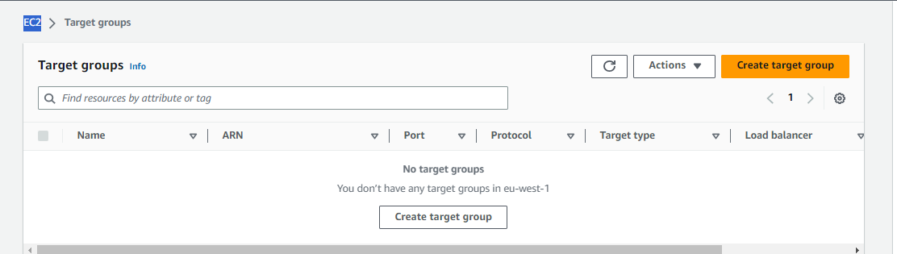

**Step 4:-**

**Now specify group details firstly choose a target type instance.**

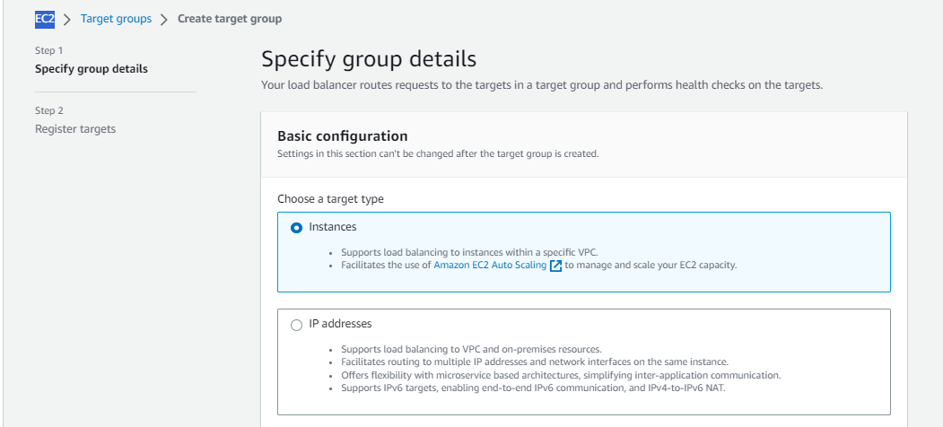

**Step 5:-**

**Now gave name to that target group.**

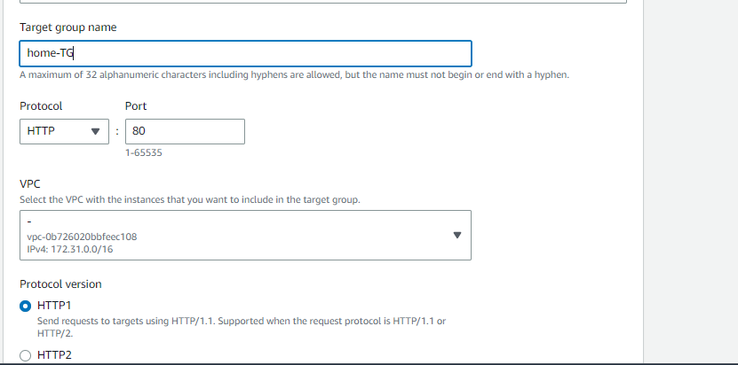

**Step 6:-**

**Now gave health check path I have not given because it is home page. And then click on next .**

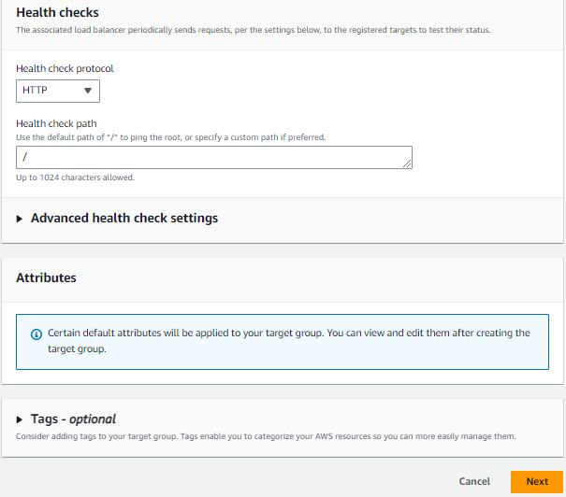

**Step 7:-**

**Then register targets means choose instance home pages. And then add them to click on include as pending below so they can addes to balance the load. And then create target group.**

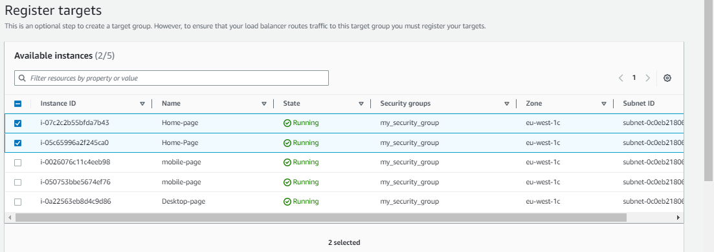

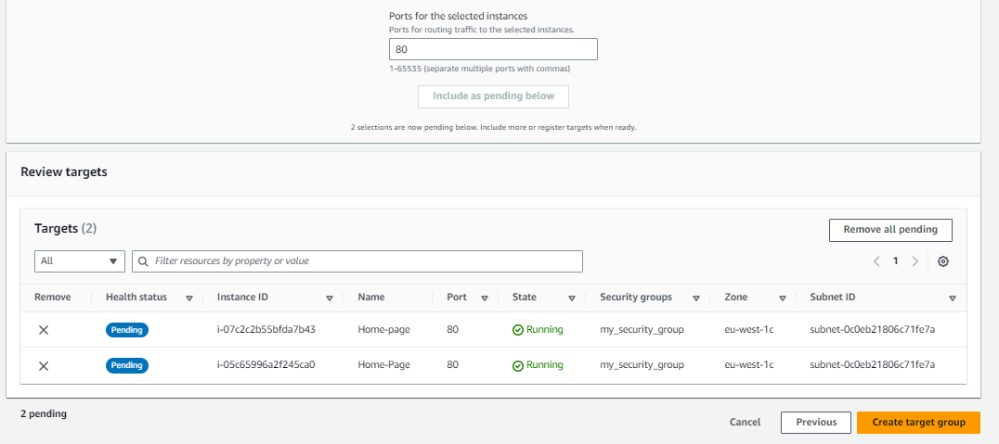

**Step 8:-**

**Now create mobile as it is specify group details.**

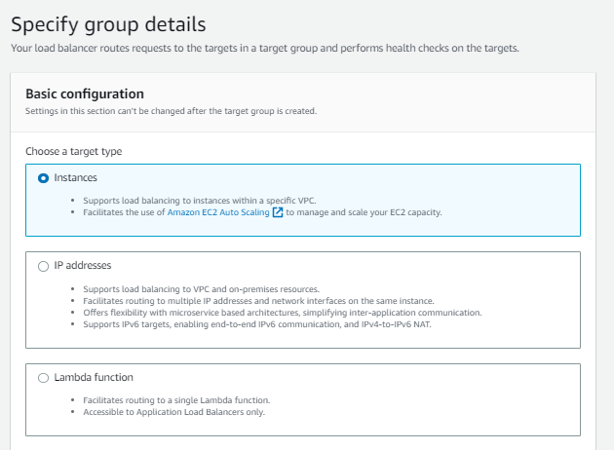

**Step 9:-**

**Now gave a target group name for mobile.**

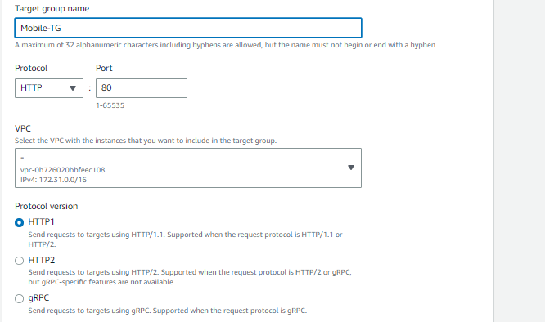

**Step 10:-**

**Now add health check path /mobile/ to health check. And click on next.**

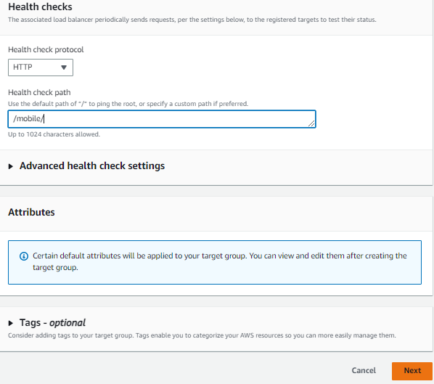

**Step 11:-**

**Then register targets means choose instance home pages. And then add them to click on include as pending below so they can addes to balance the load. And then create target group.**

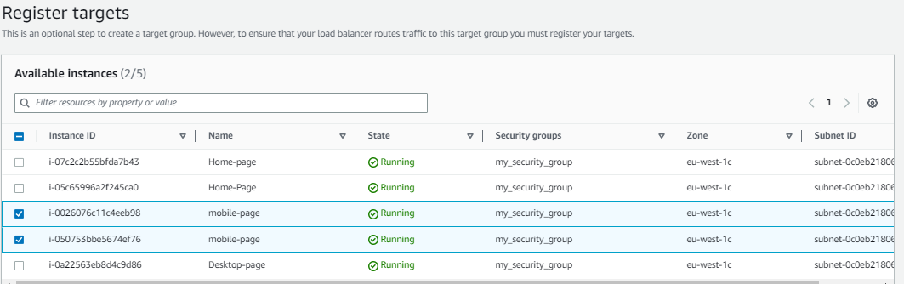

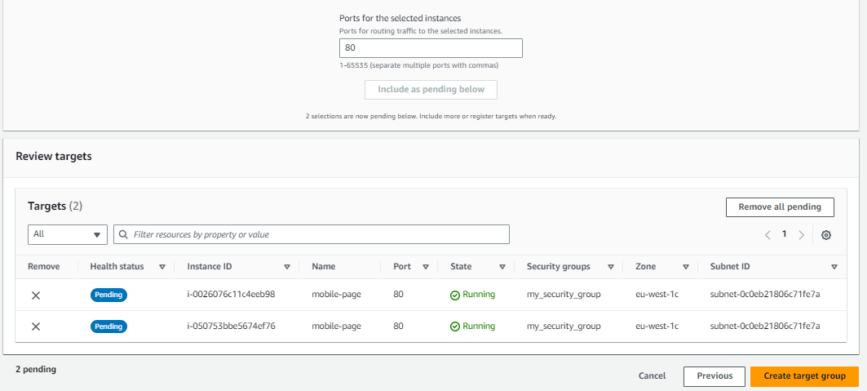

**Step 12:-**

**Now create target group for desktop page and specify group details and select target type instances.**



**Step 13:-**

**Gave a target group name .**

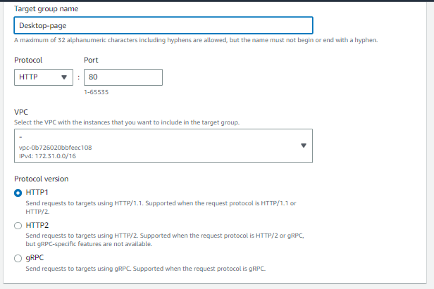

**Step 14:-**

**Now gave health check path /desktop/ to health check of desktop page.**

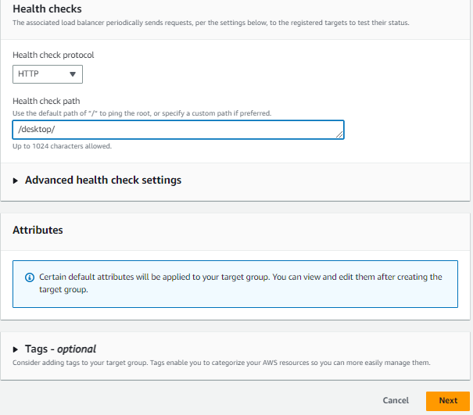

**Step 15:-**

**Then register targets means choose instance desktop pages. And then add them to click on include as pending below so they can addes to balance the load. And then create target group.** 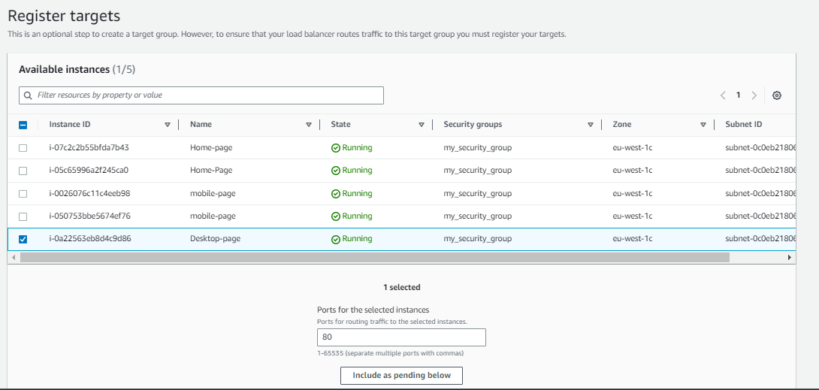

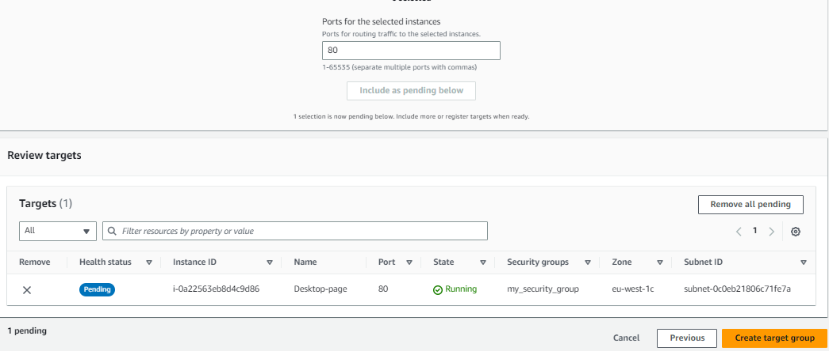

**Step 16:-**

**Now you have to create load balancer to when your instance has load then your pages are host by randomly. Go to load balancer session and click on create load balancer.**

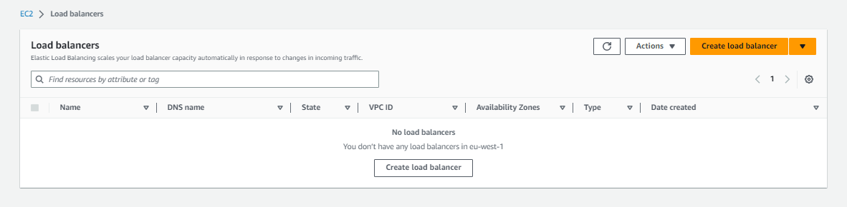

**Step 17:-**

**Select application load balancer to load balance.**

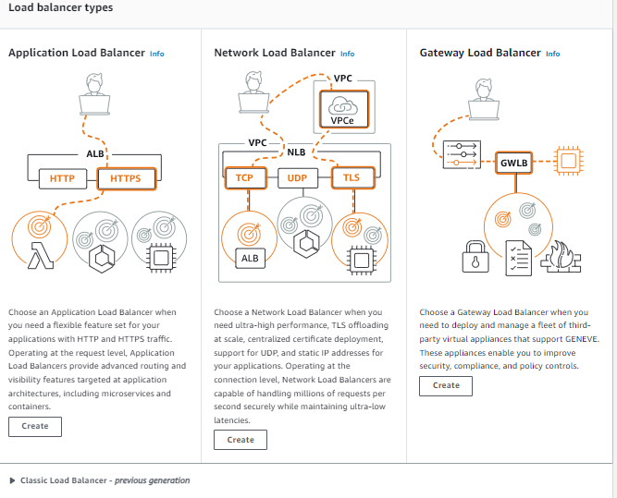

**Step 18:-**

**Now see basic configuration page first gave name to load balancer then select scheme internet-facing and then ipv4 select.**

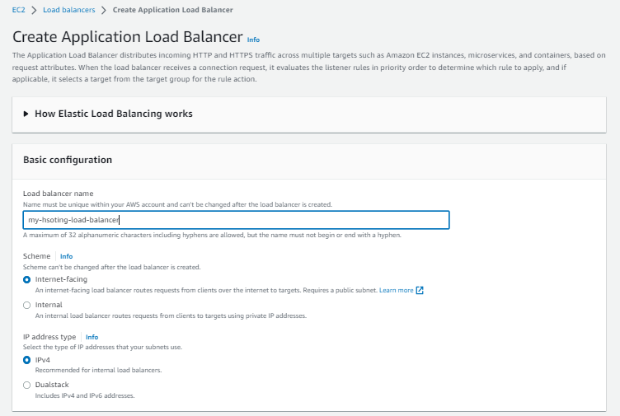

**Step 19:-**

**Now select vpc and then select region to load the balance of instance.**

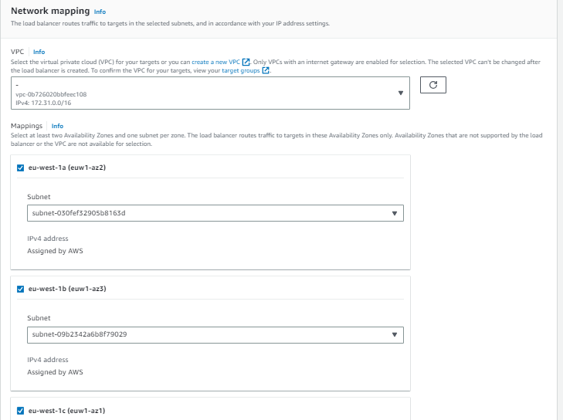

**Step 20:-**

**Now add listeners and routing it means Target group select . now I am add only home page because we can not gave one port two many. Next type a gave rule to listen mobile and desktop page listen.**

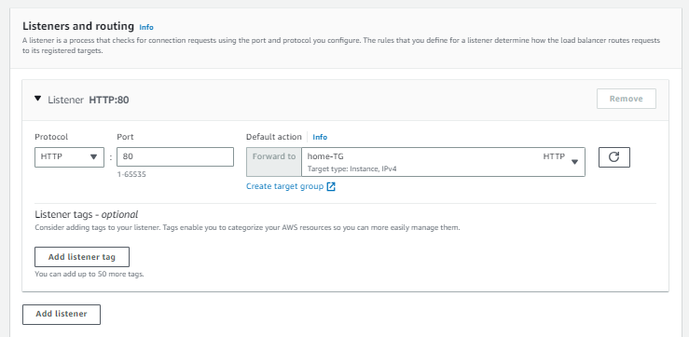

**Step 21:-**

**Now gave tag to load balance and then see summary and create load balancer.**

**And your load balancer is ready.**

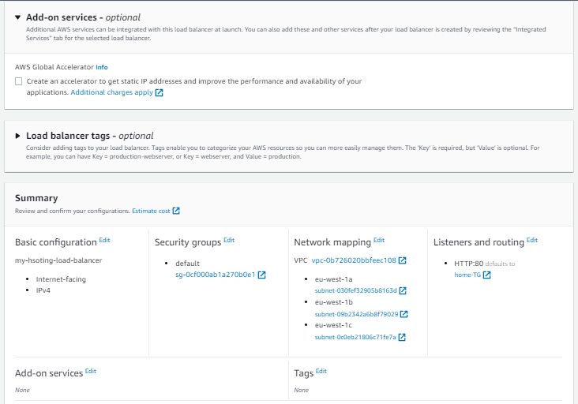

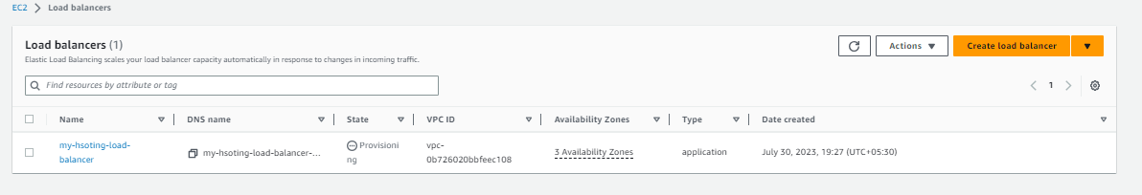

**Step 22:-**

**Now you have to add rules to load balancer because there is only one listener and pages are three so we have to apply rule of mobile page and desktop page. To that click on load balancer name and go into it. **

**Step 23:-**

**Now see down side and left corner you see http:80 protocol port click on that.**

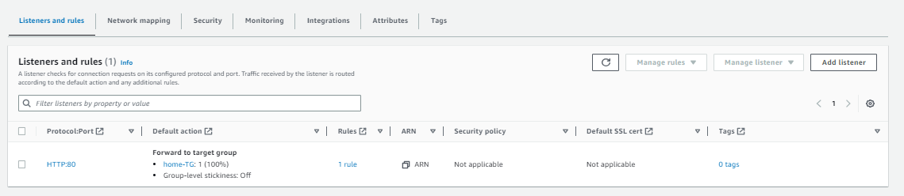

**Step 24:-**

**Now you have see the add rule option in right corner click on that option.**

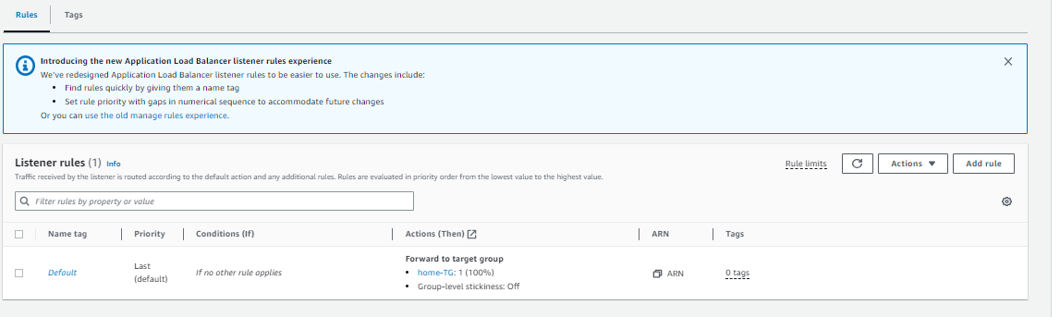

**Step 25:-**

**After that you will name and tag column gave it name of mobile. And click on next.**

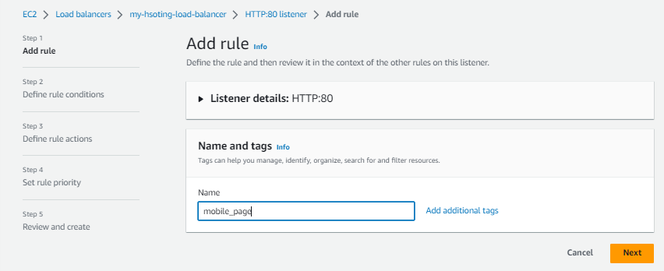

**Step 26:-**

**After that click on add condition.**

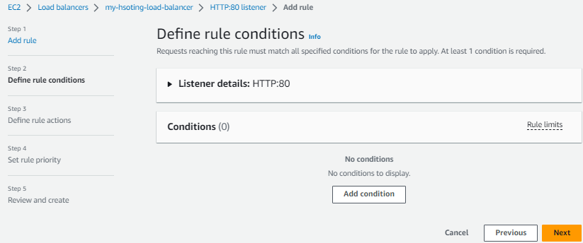

**Step 27:-**

**Now add rule condition type path. And next column gave its path /mobile/* and click on confirm.**

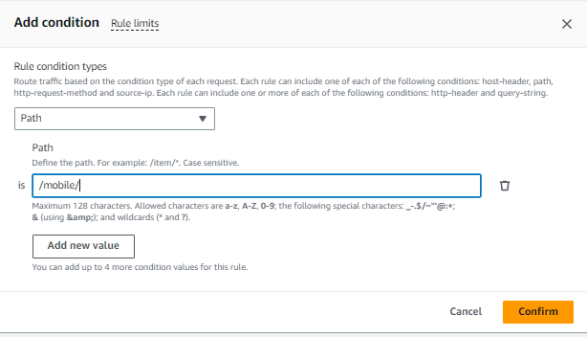

**Step 28:-**

**Now see define rule conditions and click on next.**

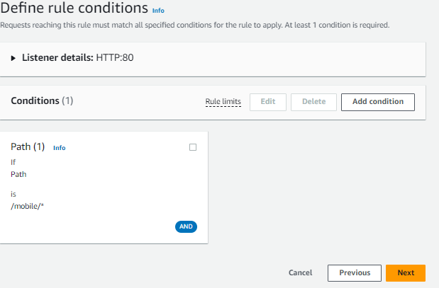

**Step 29:-**

**After that select action type and forward to target group mobile. And click on next .** 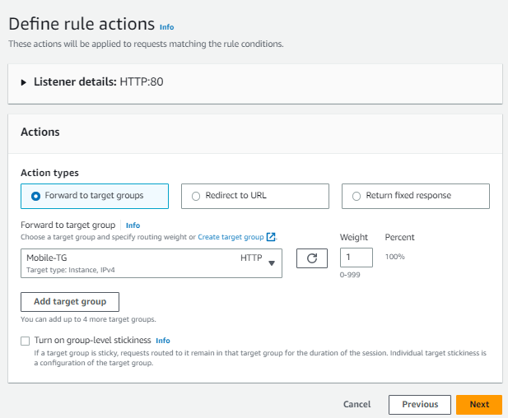

**Step 30:-**

**Now you have to syep a rule so gave priority 1 to rule and click on next.**

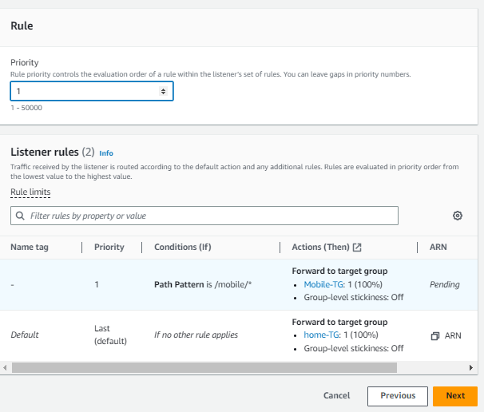

**Step 31:-**

**Review and click on create to the create rule.**

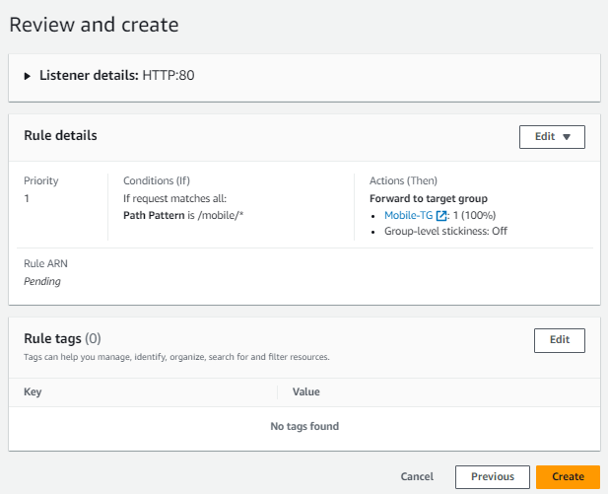

**Step 32:-**

**You have to add one more rule of desktop. So do same this process. I will show you directly step so see following images and make it .**

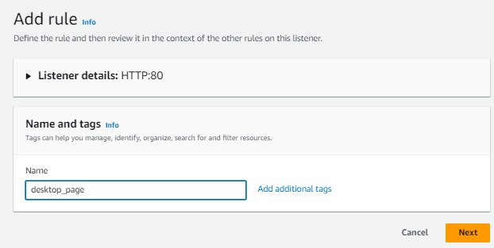

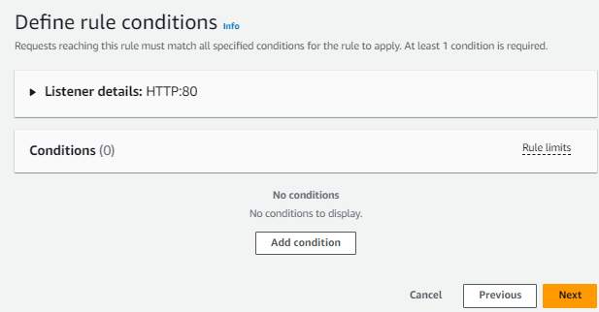

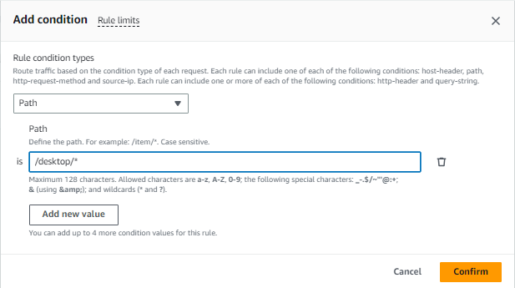

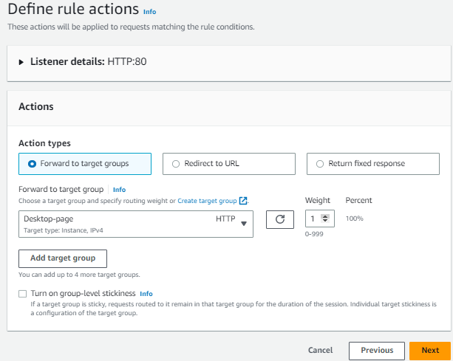

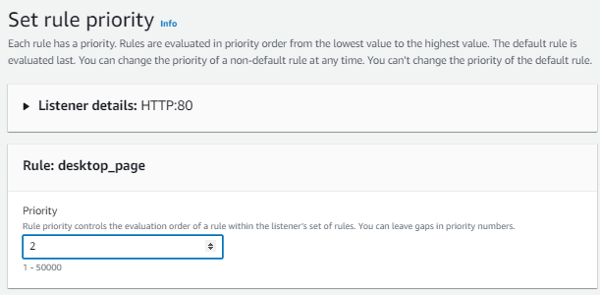

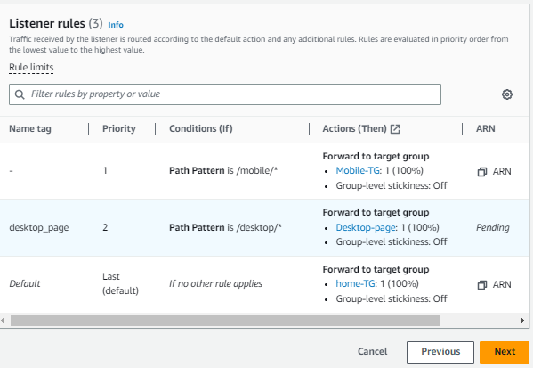

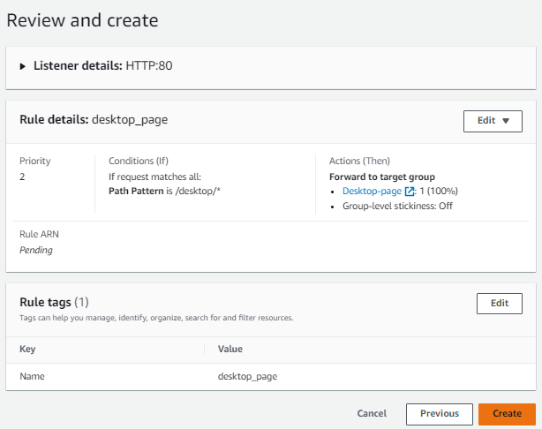

**Step 33:-**

**Now see add the rules of all pages and listens is only one.**

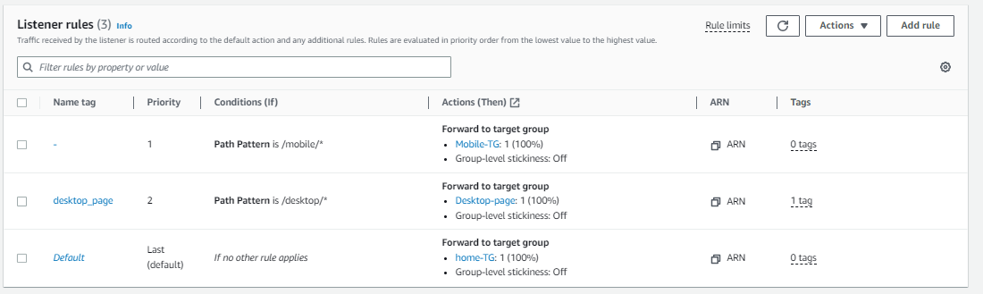

**Step 34:-**

**Now copy the DNS of load balancer and paste on new page to see your load balancer is working or not.**

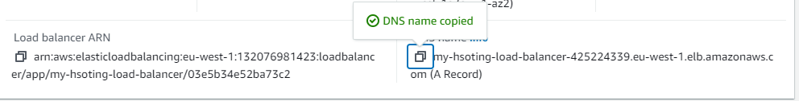

**Step 35:-**

**Now see this is home page and its load balance is working hosting same page but after refresh or if load was created then they host same page on second machine.**

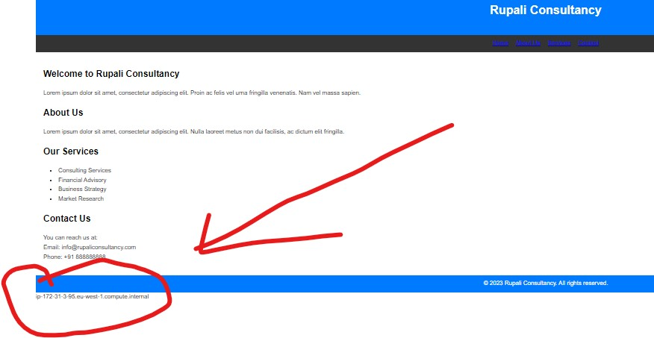

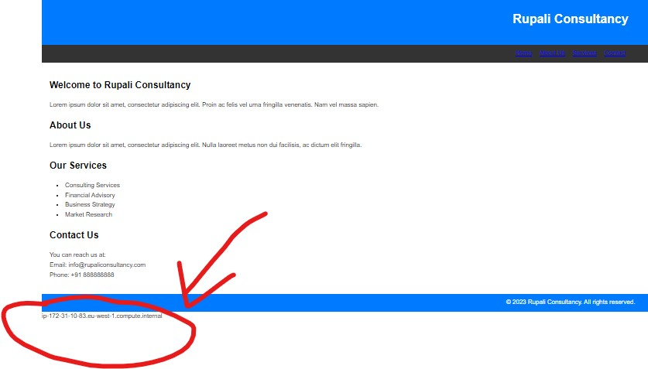

**Step 36:-**

**See in mobile page also same page but change the machine when I refresh. As it is**

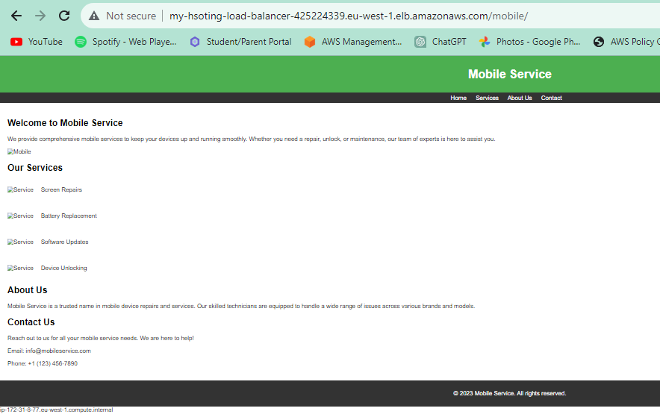

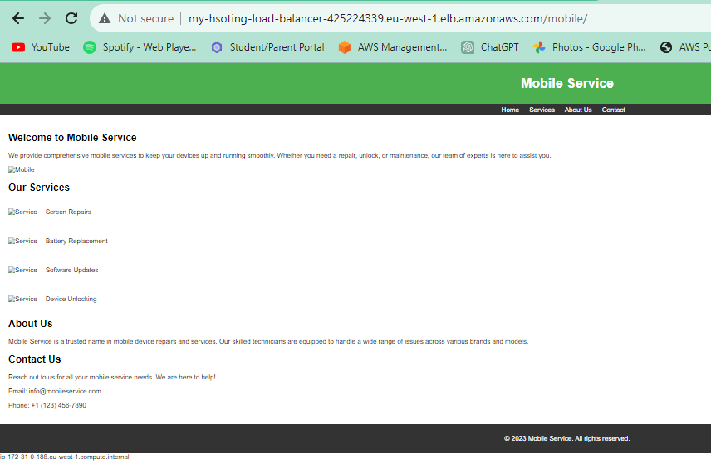

**Q.7)create autoscaling group add multiple target group also add APP load balancer on it so that it should be able to distrubute load equaly.**

**🡺**

**Step 1:-**

**Open AWS account and go to ec2 service.**



**Step 2:-**

**Now first of all you have to create templates because for auto scaling we need templates. I have already created two templates so i will show you directly how to create auto scaling groups. First go to auto scaling groups session and click on create auto scaling group.**

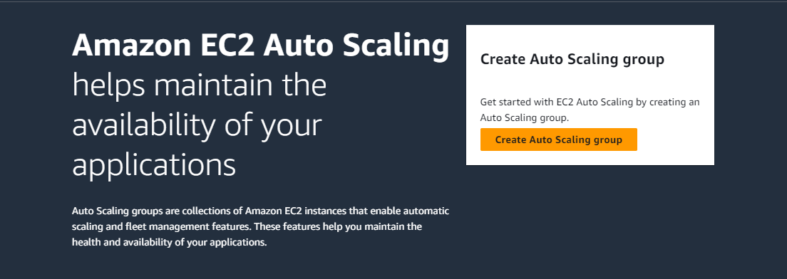

**Step 3:-**

**Now gave a name to auto scaling group .**

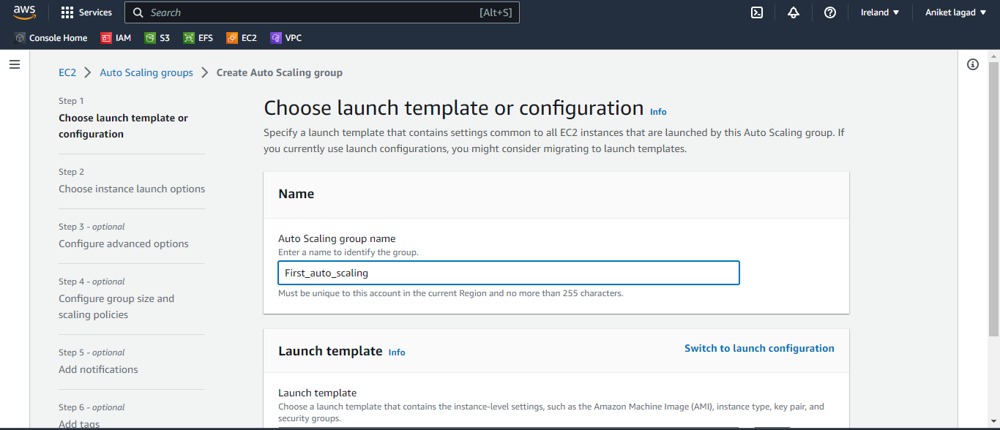

**Step 4:-**

**And after that select home template first. And then click on next.**

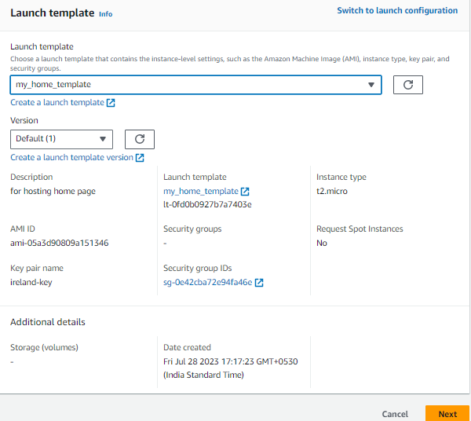

**Step 5:-**

**Now select vpc means subnet and then select availability zones and click on next.**

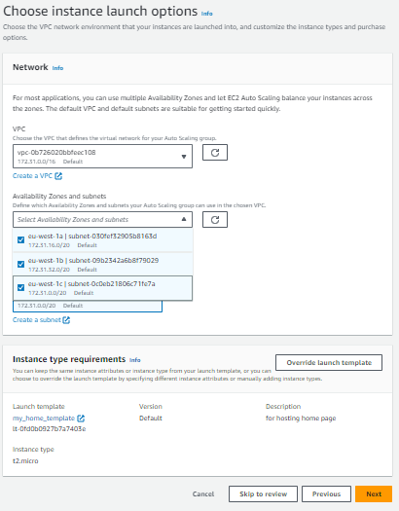

**Step 6:-**

**Now select if you already load balancer is available if not then click on no load balancer and next select no vpc lattice service.**

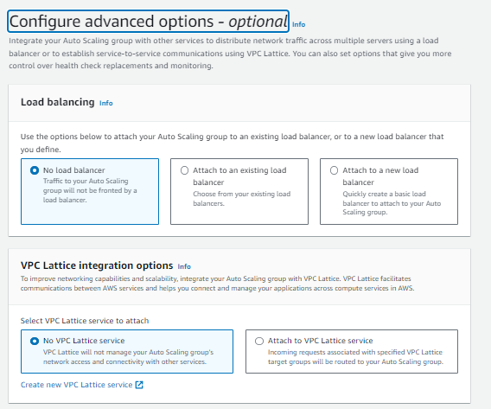

**Step 7:-**

**Now select ec2 health checks it is ohk then click if you have to set monitoring to ASG if not then click on next.**

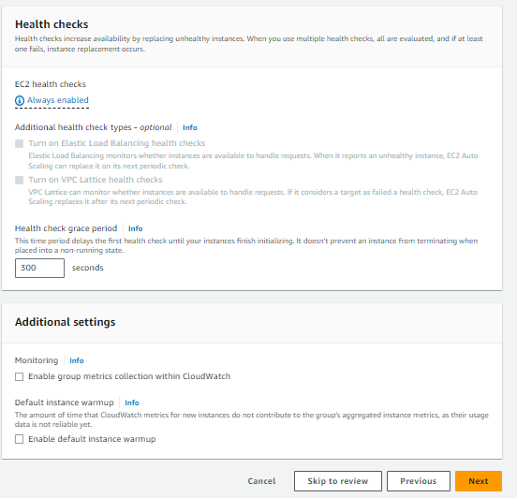

**Step 8:-**

**Now select group size it means how much you have instance noe install and how much instance launch when load is increase. Desired capacity means now 1 instance launch and minimum capacity means when your instance was on load then minimum how much instance launch and maximum capacity how much launch. That’s why I selected two launch when over load instance.**

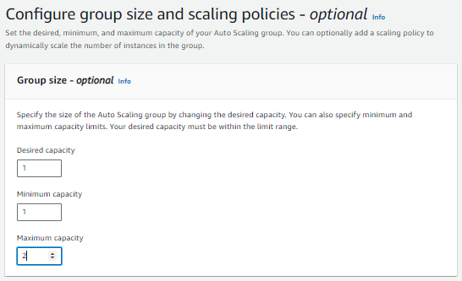

**Step 9:-**

**Now you have select scaling means how much load was required for launch new instance. I choose 50 percent. And then click on next.**

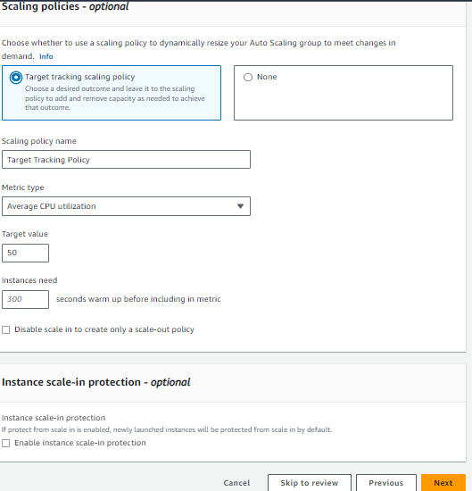

**Step 10:-**

**Next select if you want to attach SNS service to get notification. Not then click on next.**

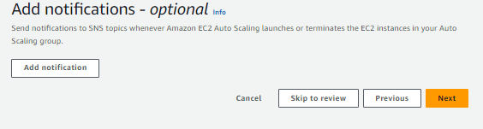

**Step 11:-**

**Now add tag when instance are to much you searches by tag.**

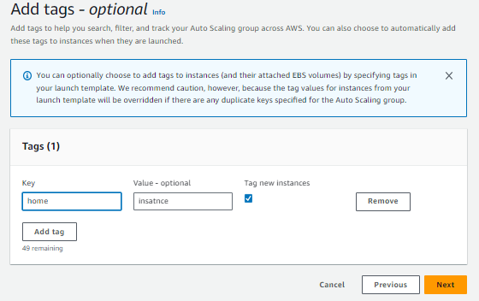

**Step 12:-**

**Now review all configuration and click on create auto scaling group. And your auto scaling group was ready.**

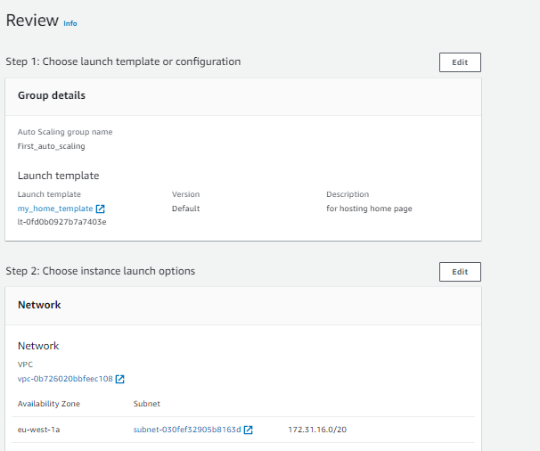

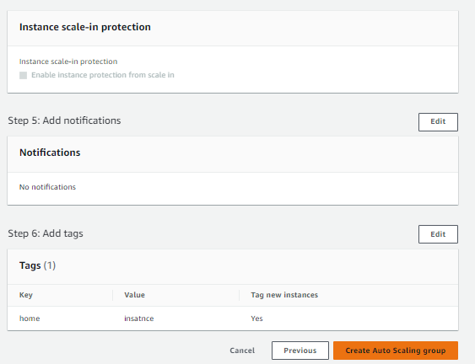

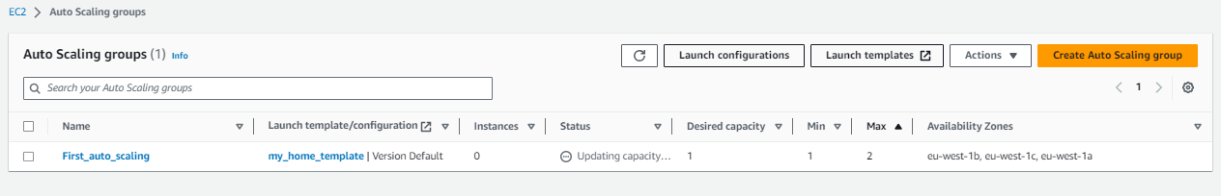

**Step 13:-**

**Now we have to create mobile auto scaling group . so see following steps and images to how to create it. Click on create launch auto scaling group. after that gave name to mobile auto scaling. And next add template to auto scaling and click on next.**

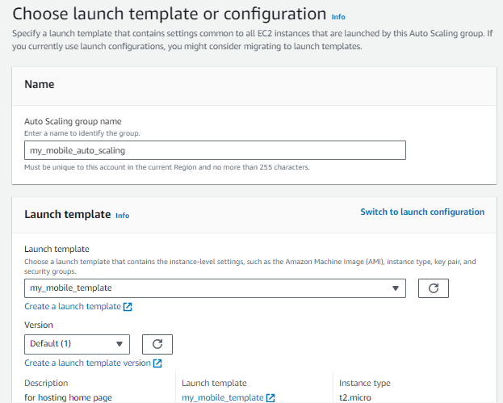

**Step 14:-**

**Next select availability zones and subnets. And click on next.**

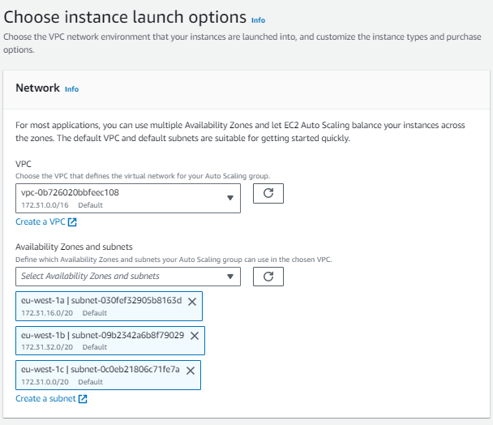

**Step 15:-**

**Now select if you already load balancer is available if not then click on no load balancer and next select no vpc lattice service.and click on next.**

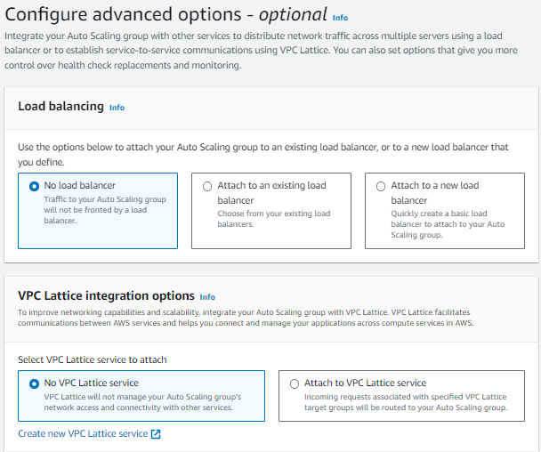

**Step 16:-**

**Now select group size it means how much you have instance noe install and how much instance launch when load is increase. Desired capacity means now 1 instance launch and minimum capacity means when your instance was on load then minimum how much instance launch and maximum capacity how much launch. That’s why I selected two launch when over load instance.** 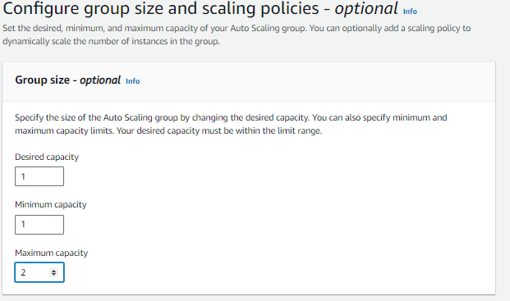

**Step 17:-**

**Now you have select scaling means how much load was required for launch new instance. I choose 50 percent. And then click on next.**

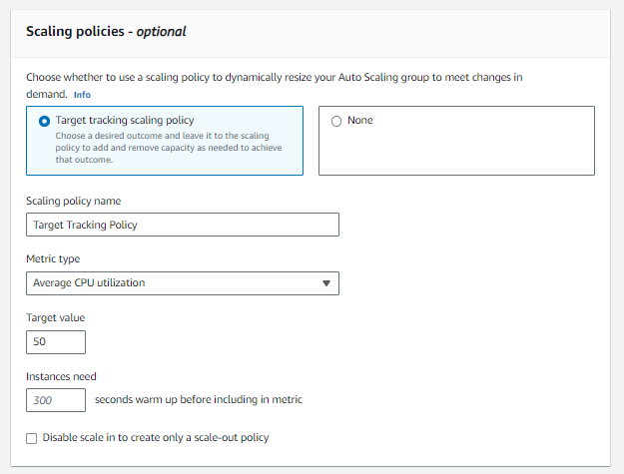

**Step 18:-**

**Now second auto scaling group of mobile is ready.**

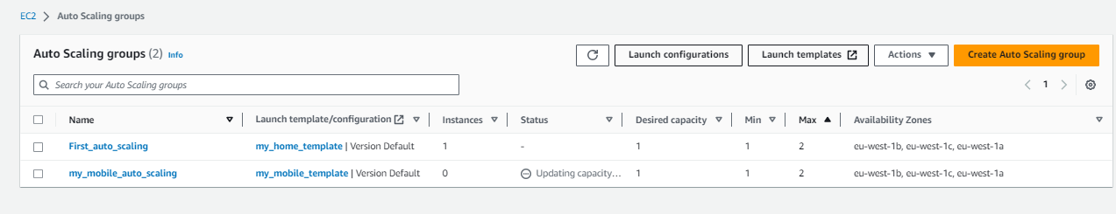

**Step 19:-**

**Now you have to create target groups to attach auto scaling then auto scaling’s instance has applied load balancer whenever your instance by auto scaling then it automatically goes load balancer. So I have already created target groups and load balancer so I have to only attach to each other.**

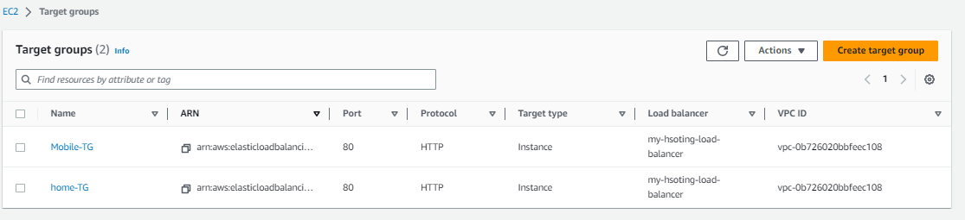

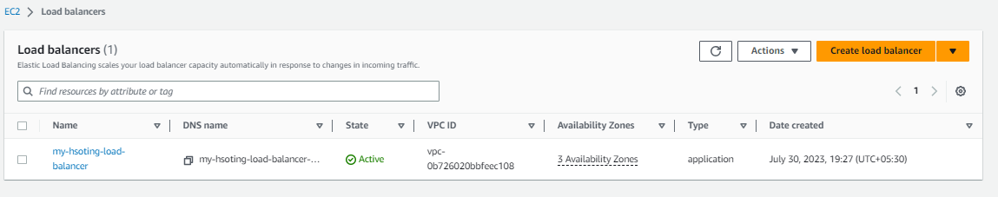

**Step 20:-**

**Go auto scaling groups session and select on first auto scaling means home page and click on actinons and after that edit.**

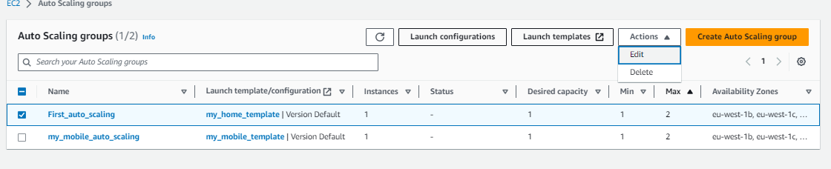

**Step 21:-**

**Now scroll down and search load balancing option and in that click application network or gateway load balancer target groups so you have to see option to select target groups I select home page target group and that target group already added to load balancer.**

**After that go down side ad click update.**

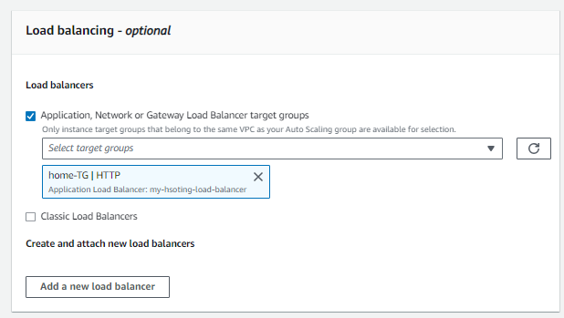

**Step 22:-**

**Now mobile auto scaling group and click on actinons and after that edit.**

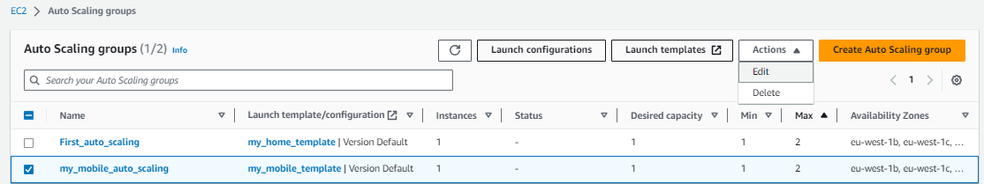

**Step 23:-**

**Now scroll down and search load balancing option and in that click application network or gateway load balancer target groups so you have to see option to select target groups no I have selected mobile page target group and that target group already added to load balancer.After that go down side ad click update.**

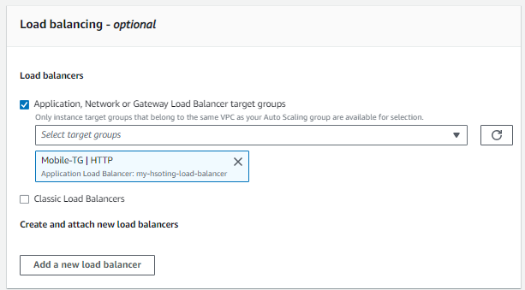

**Step 24:-**

**Go to instance session see your auto scaling instance are running or not.** 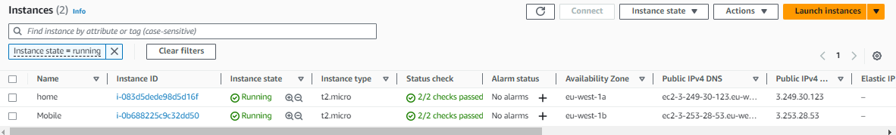

**Step 25:-**

**Now I have to increase a stress or load of instance for see auto scaling is running or not. So I get on access of home instance on cli and increase load by run command stress.**

**See load was increased and cross 50 level I was set a 50 load level now I go to aws console and see instance auto scaling is created new instance or not. And also its load balancer would be working or not .**

**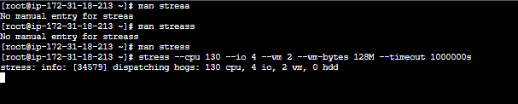  
home Load**

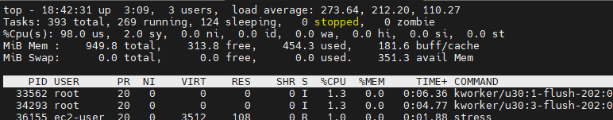

**Mobile load**

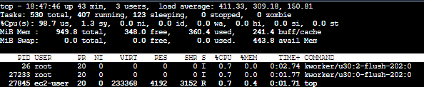

**Step 26:-**

**Now see auto scaling is working and also load balancer is working.**

